Children’s Mental Health Week

Wellbeing bingo – can you try and cross all these out by the end of the week? If you don’t have a pet, you could give someone in your family bubble a big hug ☺

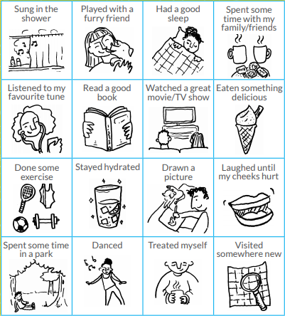

Called family or a friend for a chat.

Been for a walk without moaning.

outdoors