Y3F
What to do today
IMPORTANT Parent or Carer – Read this page with your child and check that you are happy with what they have to do and any weblinks or use of internet.
Please note that the clips are from the films which are classified as PG for some ‘scary moments’ and ‘mild bad language’ which you may not feel is appropriate for your child.

1. Read an extract from Harry Potter
- Read The Sorting Hat. Have you read or seen this part of the story before? How do you think you would feel if you were there in the Great Hall?
- Watch the film version of this scene. Which part of the scene do you think that the film does best?
https://www.youtube.com/watch?v=A0cla_h_f8M
2. Remind yourself about clauses and conjunctions
- Use the PowerPoint to hear the teaching on Clauses and Conjunctions or use the Revision Card remind yourself.
- Complete the Conjunctions Activity. You can use the List of Conjunctions to help you.

3. Write some sentences
- Watch the film clip of the Sorting Hat again.
- Now write some sentences about the scene. Use conjunctions in your sentences, using the List of Conjunctions.

Well done! Now show a grown-up your sentences. Show them the conjunctions that you have used and clauses that you have joined.

Try these Fun-Time Extras
- Can you find out which house you belong to? Ask a grown-up to help you register and then use this Sorting Ceremony website:
https://my.wizardingworld.com/sorting-hat/intro

The Sorting Hat

The door swung open at once. A tall, black-haired witch in emerald-green robes stood there. She had a very stern face and Harry’s first thought was that this was not someone to cross. | 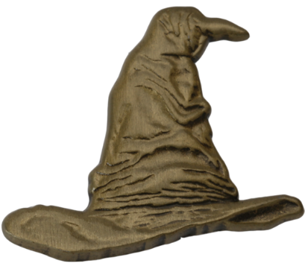
‘The firs’-years, Professor McGonagall,’ said Hagrid.
‘Thank you, Hagrid. I will take them from here.’

She pulled the door wide. The Entrance Hall was so big you could have fitted the whole of the Dursleys’ house in it. The stone walls were lit with flaming torches like the ones at Gringotts, the ceiling was too high to make out, and a magnificent marble staircase facing them led to the upper floors.

They followed Professor McGonagall across the flagged stone floor. Harry could hear the drone of hundreds of voices from a doorway to the right – the rest of the school must already be here – but Professor McGonagall showed the first-years into a small empty chamber off the hall. They crowded in, standing rather closer together than they would usually have done, peering about nervously.

‘Welcome to Hogwarts,’ said Professor McGonagall. ‘The start-of-term banquet will begin shortly, but before you take your seats in the Great Hall, you will be sorted into your houses. The Sorting is a very important ceremony because, while you are here, your house will be something like your family within Hogwarts. You will have classes with the rest of your house, sleep in your house dormitory and spend free time in your house common room.

From: JK Rowling - Harry Potter and the Philosopher's Stone
Revision Card – Conjunctions

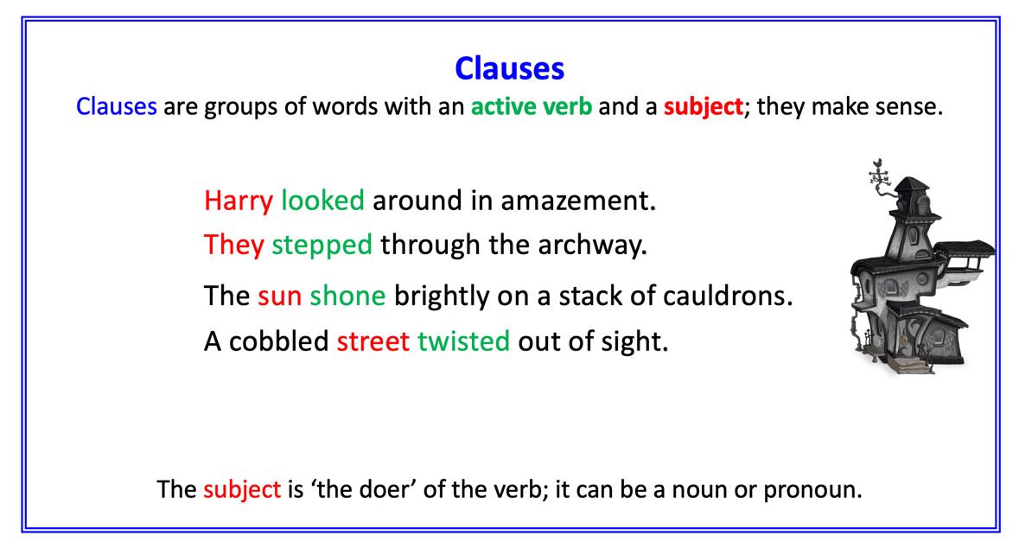 | 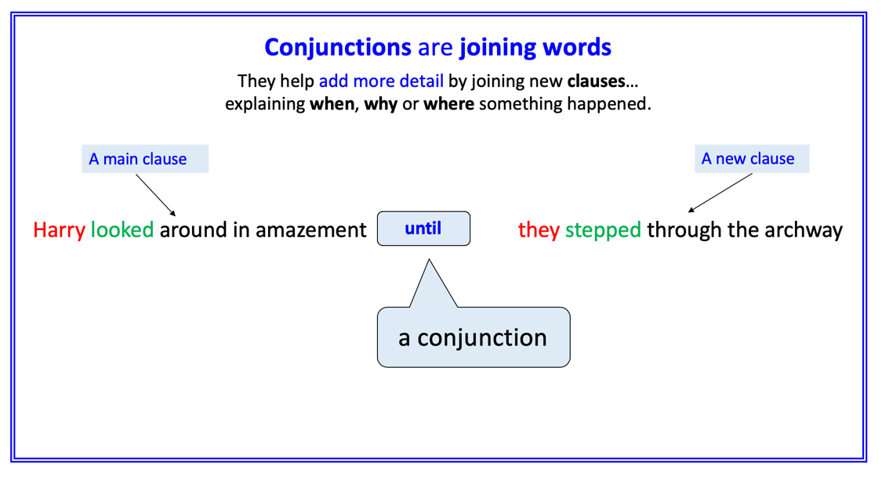
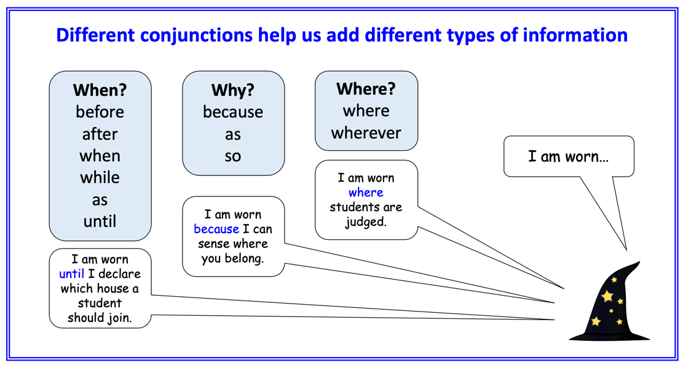 | 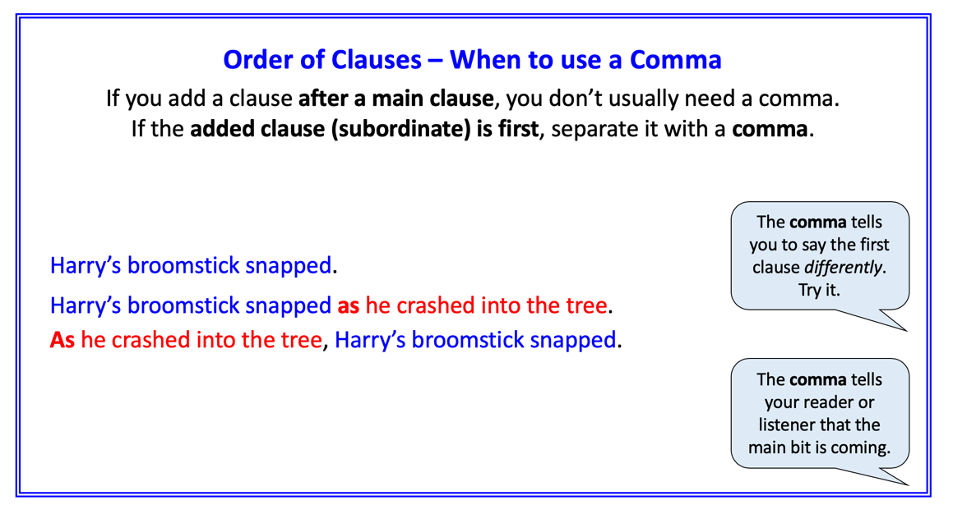

Conjunctions Activity

Highlight the clauses and underline the conjunctions in these sentences.
Re-write the sentence using a different conjunction.
Does this change the meaning of the sentence?

Hermione smiled with satisfaction while aiming the curse at Draco.
Hermione smiled with satisfaction after aiming the curse at Draco.

Hermione made a disappearing spell while Professor Snape wasn’t looking.

Harry Potter released Hedwig because Dudley hurt him.

Ron skidded along the floor when it was wet.

Dudley’s shirt buttons popped open as he ate his roast dinner.

The snake slithered quickly because he was hurt.

The Whomping Willow tried to hit Hermione because she was too near.

The Great Hall was lit with a thousand candles because it was dark outside.

Hagrid fed his dragon when he left for Privet Drive.

Moaning Myrtle cried in the toilets because she ran away.

List of Conjunctions

When?
before
after
when
while
as
until

Why?
because
as
so

Where?
where
wherever

Sorting Hat Sentences

Watch the Sorting Hat scene and write some sentences here about it using conjunctions.

Conjunctions Activity - ANSWERS

Highlight the clauses and underline the conjunctions in these sentences.
Re-write the sentence using a different conjunction.
The second answers are suggestions only – other answers will be acceptable.

Hermione smiled with satisfaction while aiming the curse at Draco.
Hermione smiled with satisfaction after aiming the curse at Draco.

Hermione made a disappearing spell while Professor Snape wasn’t looking.
Hermione made a disappearing spell because Professor Snape wasn’t looking.

Harry Potter released Hedwig because Dudley hurt him.
Harry Potter released Hedwig before Dudley hurt him.

Ron skidded along the floor when it was wet.
Ron skidded along the floor because it was wet.

Dudley’s shirt buttons popped open as he ate his roast dinner.
Dudley’s shirt buttons popped open after he ate his roast dinner.

The snake slithered quickly because he was hurt.
The snake slithered quickly before he was hurt.

The Whomping Willow tried to hit Hermione because she was too near.
The Whomping Willow tried to hit Hermione since she was too near.

The Great Hall was lit with a thousand candles because it was dark outside.
The Great Hall was lit with a thousand candles before it was dark outside.

Hagrid fed his dragon when he left for Privet Drive.
Hagrid fed his dragon after he left for Privet Drive.

Moaning Myrtle cried in the toilets because she ran away.
Moaning Myrtle cried in the toilets when she ran away.

