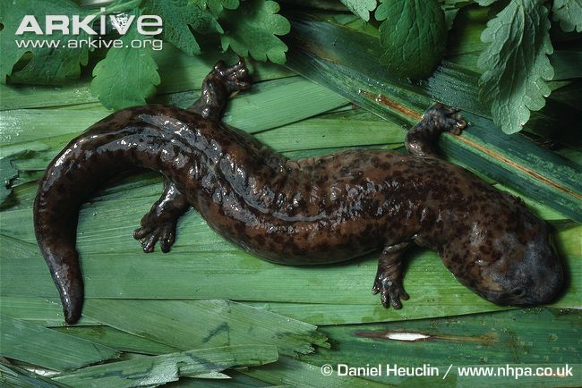 | Name: Chinese giant salamander  Status:  Range:  Why am I threatened?
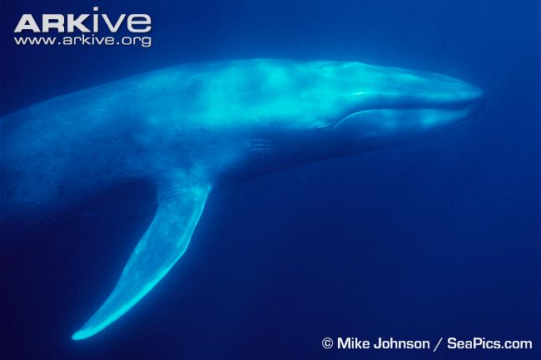 | Name: Blue whale  Status:  Range:  Why am I threatened?
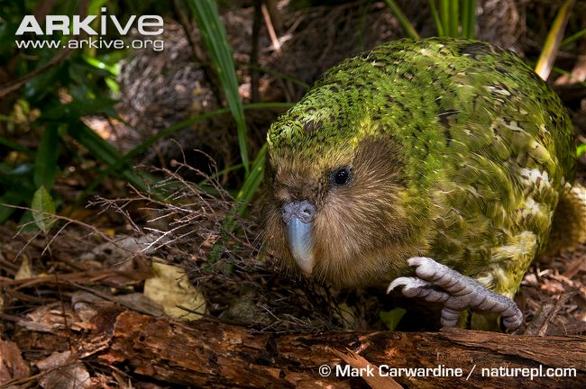 | Name: Kakapo  Status:  Range:  Why am I threatened?
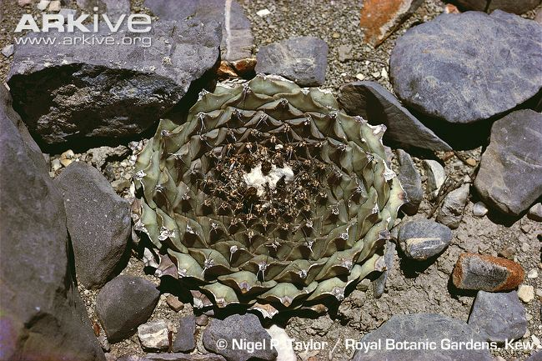 | Name: Artichoke cactus  Status:  Range:  Why am I threatened?
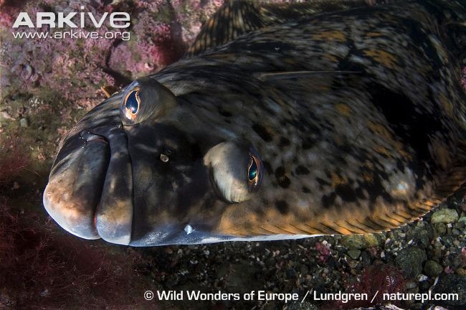 | Name: Atlantic halibut  Status:  Range:  Why am I threatened?
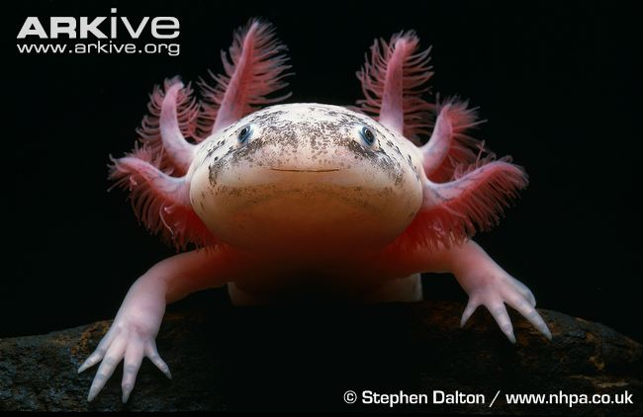 | Name: Axolotl  Status:  Range:  Why am I threatened?
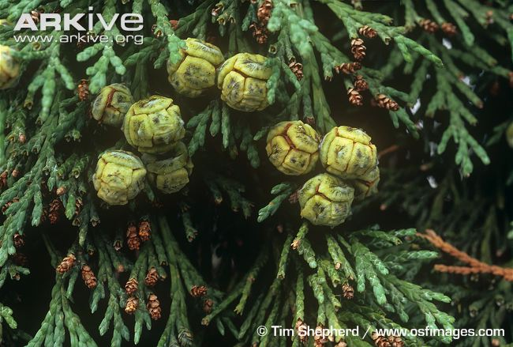 | Name: Lawson’s cypress  Status:  Range:  Why am I threatened?
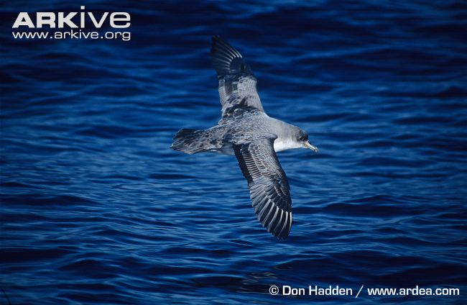 | Name: Grey petrel  Status:  Range:  Why am I threatened?
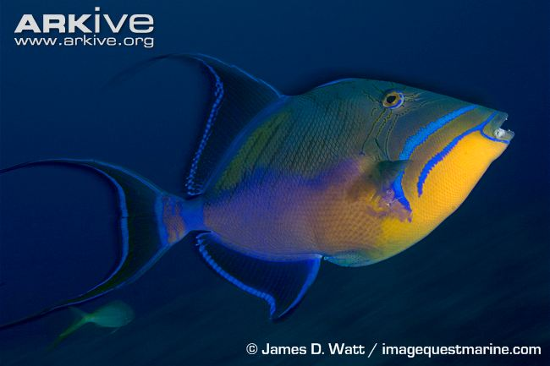 | Name: Queen triggerfish  Status:  Range:  Why am I threatened?
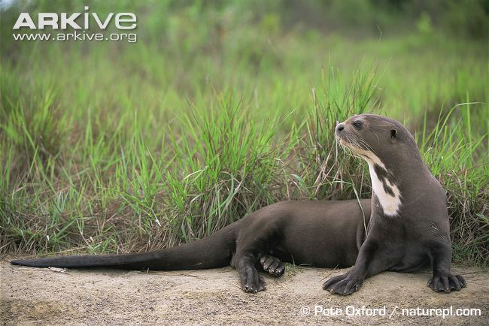 | Name: Giant otter  Status:  Range:  Why am I threatened?
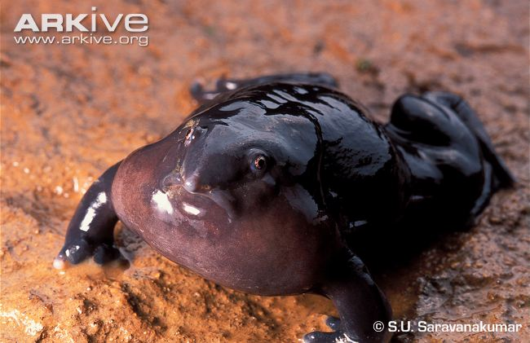 | Name: Purple frog  Status:  Range:  Why am I threatened?
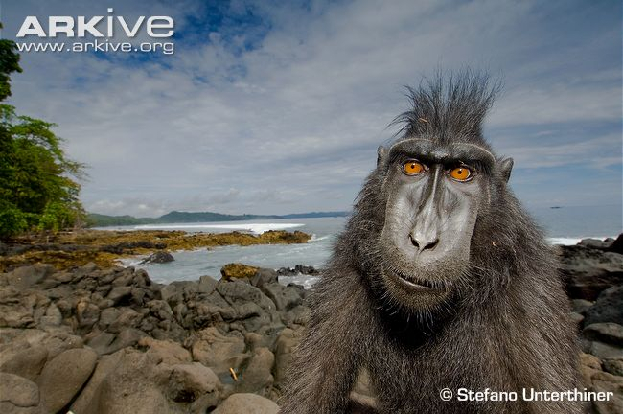 | Name: Crested black macaque  Status:  Range:  Why am I threatened?
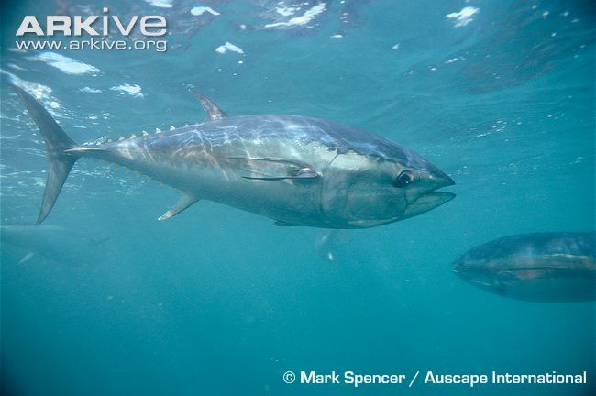 | Name: Southern bluefin tuna  Status:  Range:  Why am I threatened?
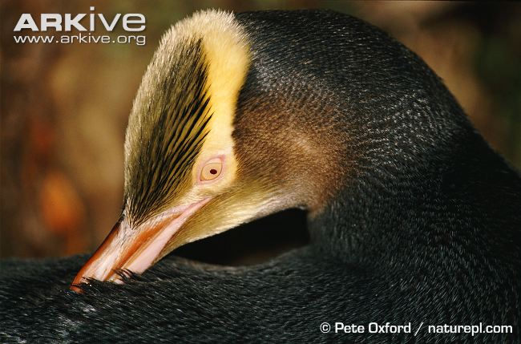 | Name: Yellow-eyed penguin  Status:  Range:  Why am I threatened?
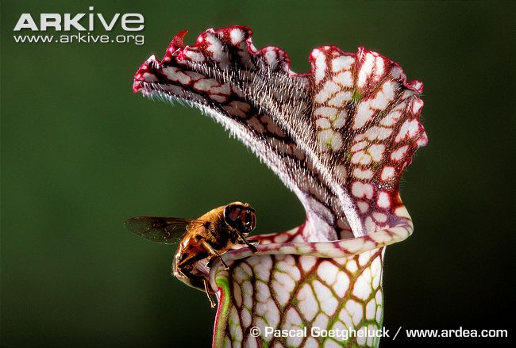 | Name: White-topped pitcher plant  Status:  Range:  Why am I threatened?
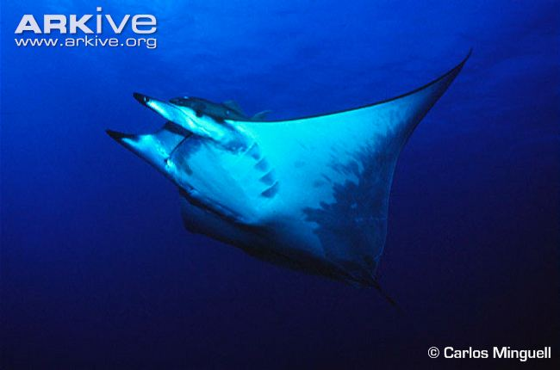 | Name: Giant devilray  Status:  Range:  Why am I threatened?
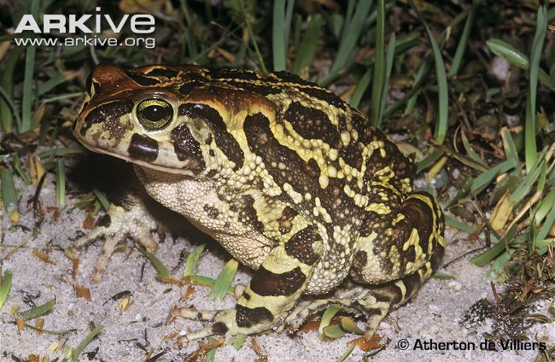 | Name: Western leopard toad  Status:  Range:  Why am I threatened?
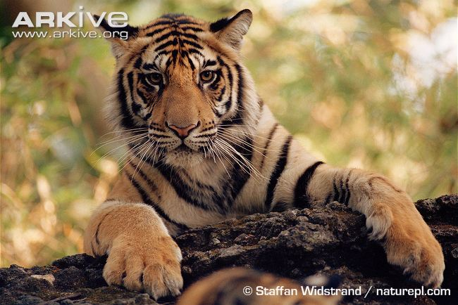 | Name: Tiger  Status:  Range:  Why am I threatened?
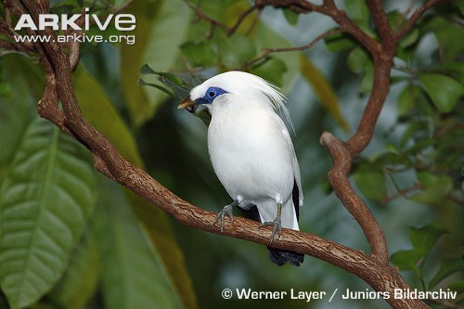 | Name: Bali starling  Status:  Range:  Why am I threatened?
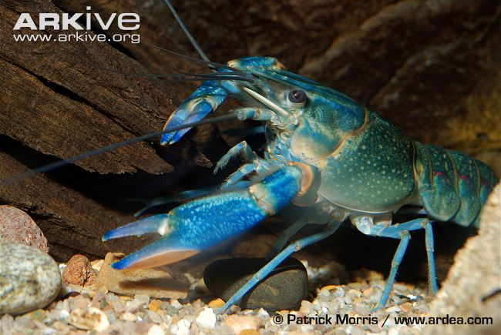 | Name: Yabbie crayfish  Status:  Range:  Why am I threatened?

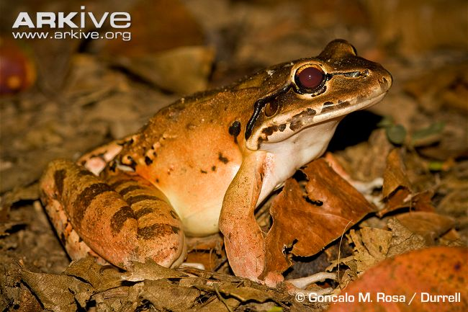 | Name: Mountain chicken  Status:  Range:  Why am I threatened?
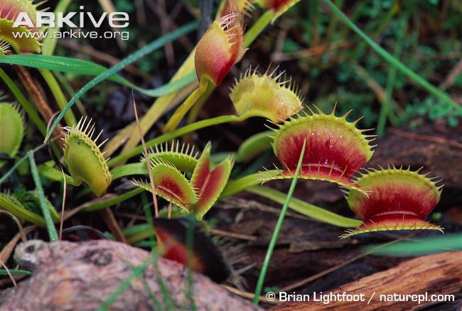 | Name: Venus flytrap  Status:  Range:  Why am I threatened?
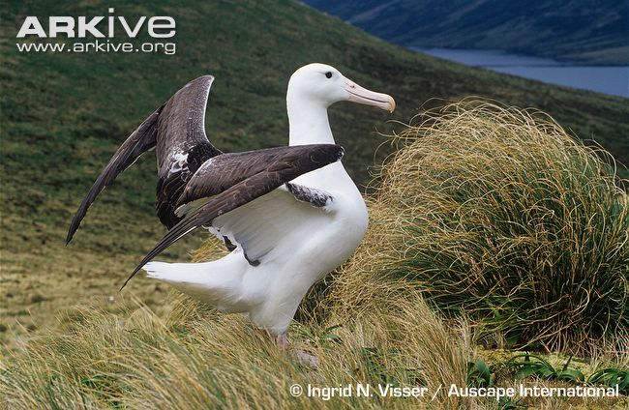 | Name: Southern royal albatross  Status:  Range:  Why am I threatened?
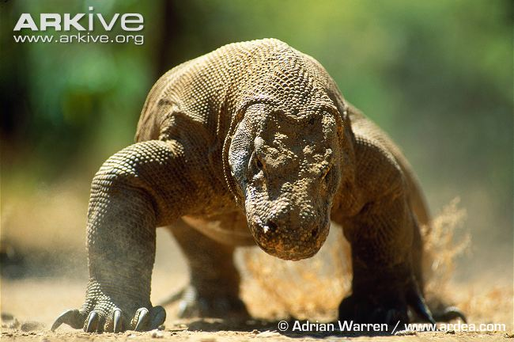 | Name: Komodo dragon  Status:  Range:  Why am I threatened?
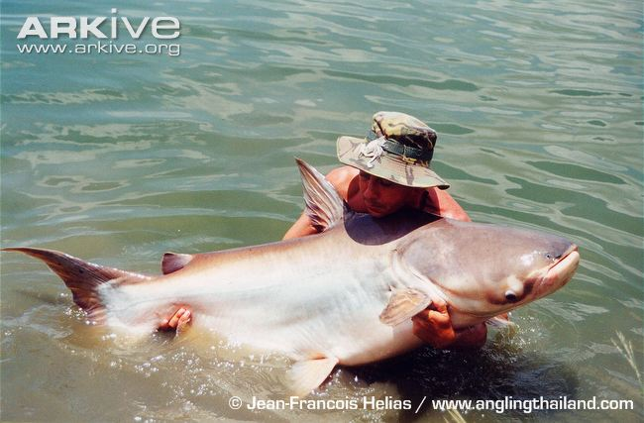 | Name: Giant catfish  Status:  Range:  Why am I threatened?
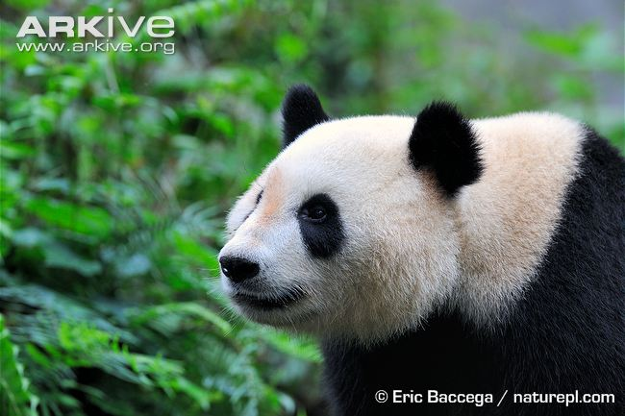 | Name: Giant panda  Status:  Range:  Why am I threatened?
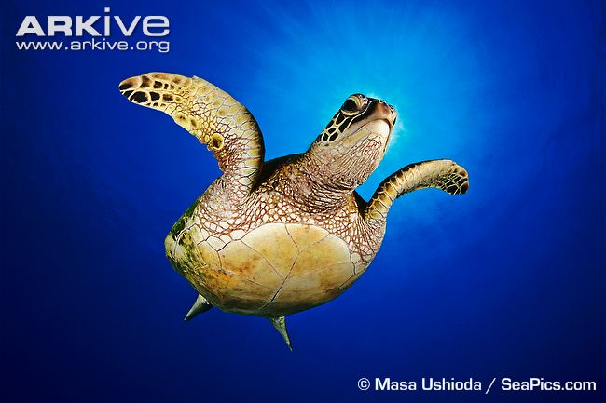 | Name: Green turtle  Status:  Range:  Why am I threatened?
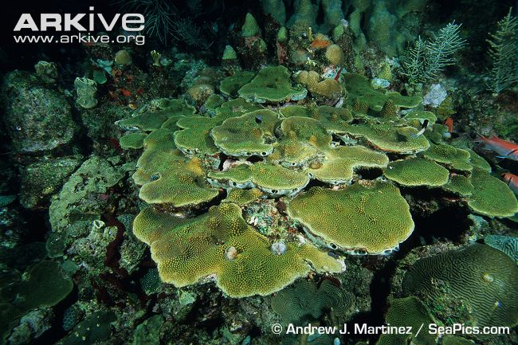 | Name: Boulder star coral  Status:  Range:  Why am I threatened?
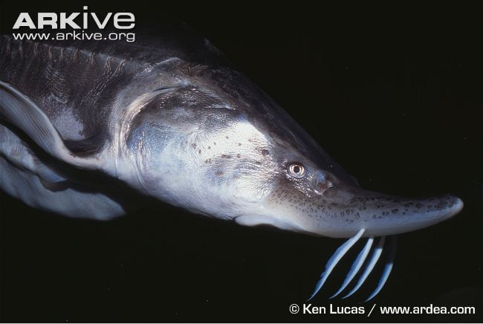 | Name: Beluga  Status:  Range:  Why am I threatened?
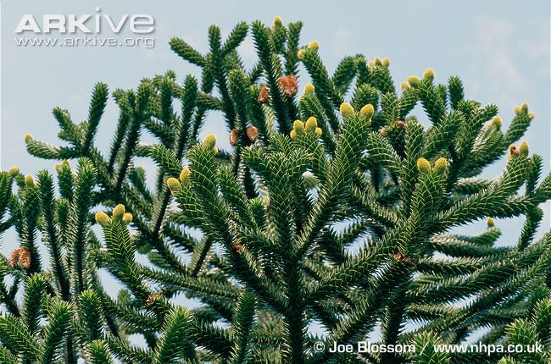 | Name: Monkey puzzle  Status:  Range:  Why am I threatened?
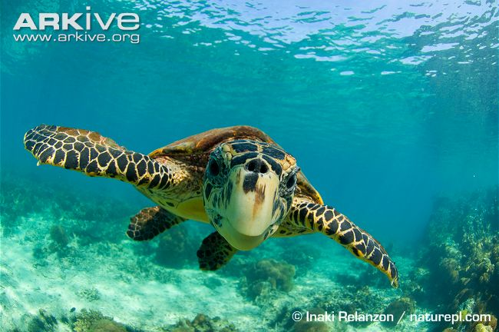 | Name: Hawksbill turtle  Status:  Range:  Why am I threatened?
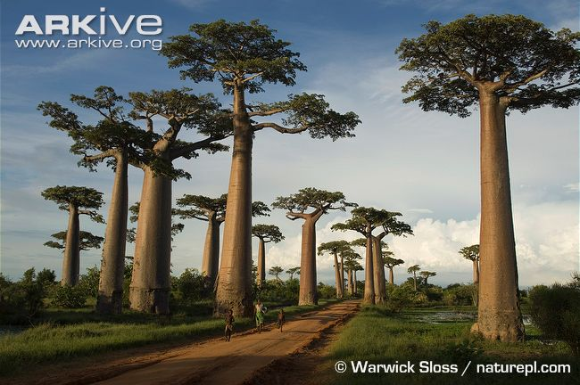 | Name: Grandidier’s baobab  Status:  Range:  Why am I threatened?
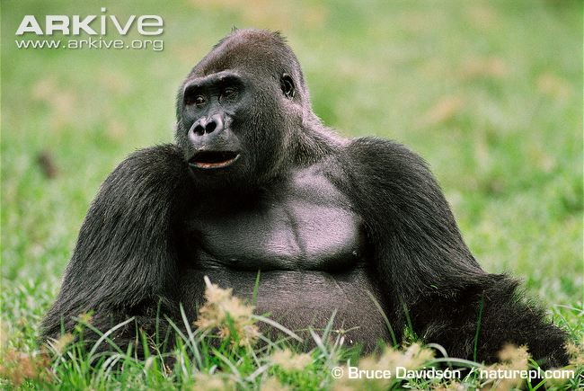 | Name: Western gorilla  Status:  Range:  Why am I threatened?
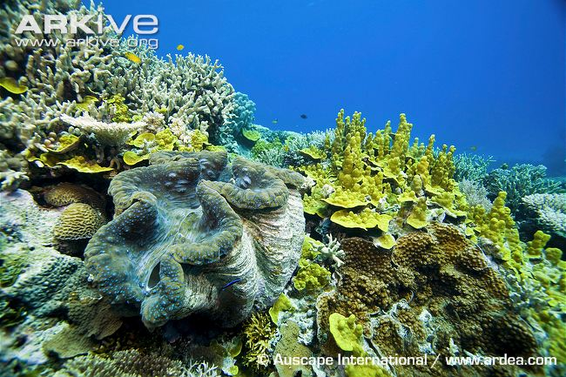 | Name: Giant clam  Status:  Range:  Why am I threatened?
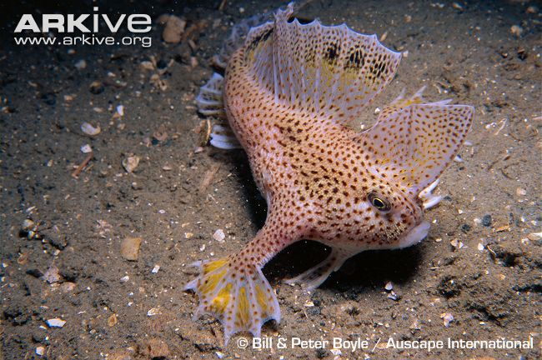 | Name: Spotted handfish  Status:  Range:  Why am I threatened?
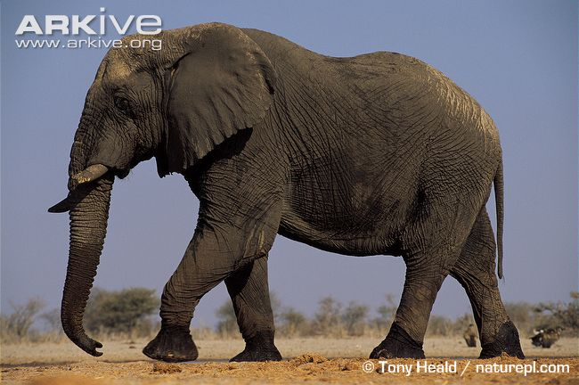 | Name: African elephant  Status:  Range:  Why am I threatened?
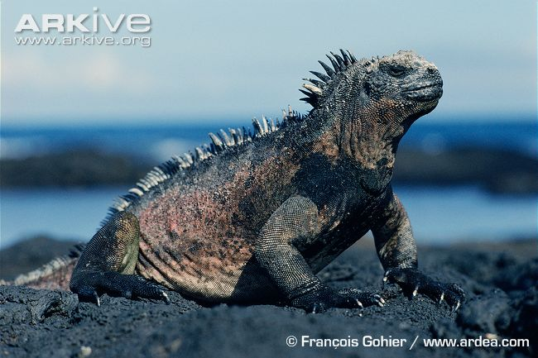 | Name: Galapagos marine iguana  Status:  Range:  Why am I threatened?  .
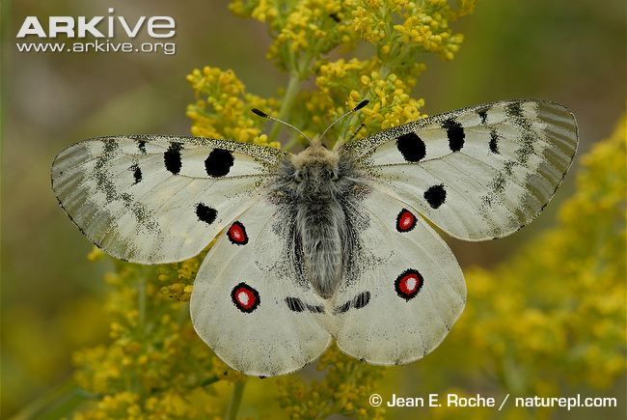 | Name: Apollo butterfly  Status:  Range:  Why am I threatened?
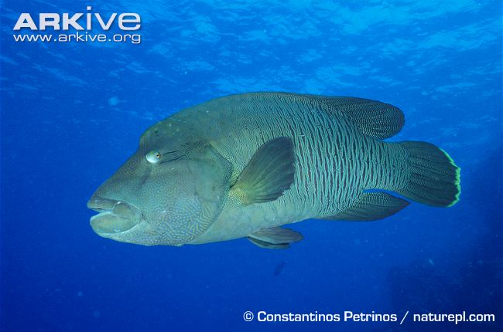 | Name: Humphead wrasse  Status:  Range:  Why am I threatened?
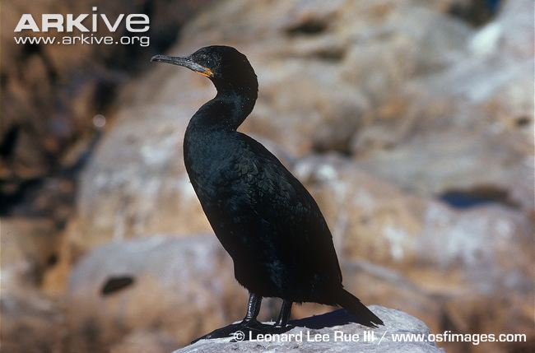 | Name: Cape cormorant  Status:  Range:  Why am I threatened?
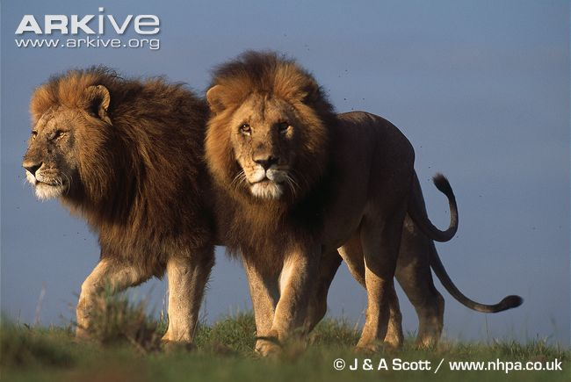 | Name: Lion  Status:  Range:  Why am I threatened?
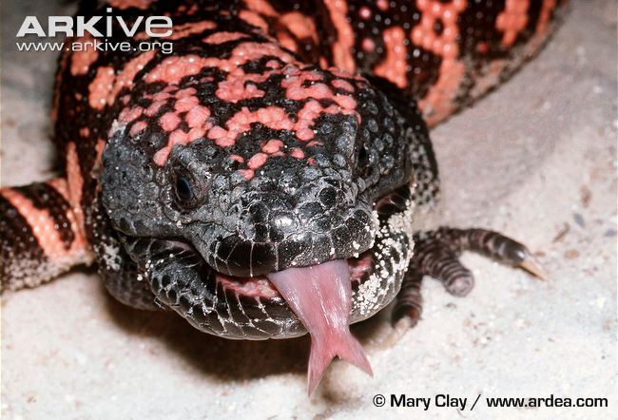 | Name: Gila monster  Status:  Range:  Why am I threatened?
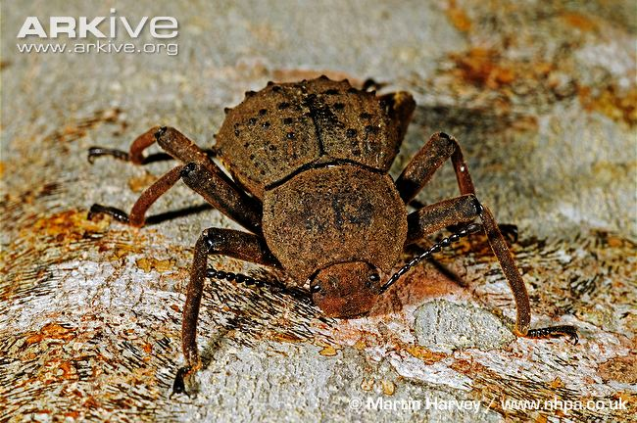 | Name: Frigate Island giant tenebrionid beetle  Status:  Range:  Why am I threatened?
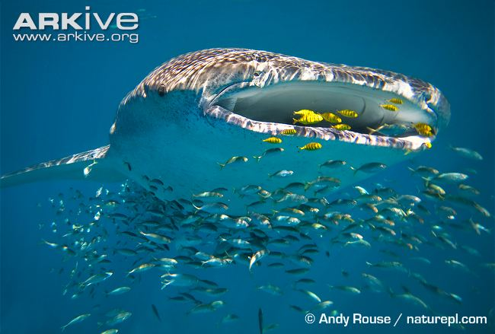 | Name: Whale shark  Status:  Range:  Why am I threatened?
Name: White-topped pitcher plant
Status:
Range:

Why am I threatened?

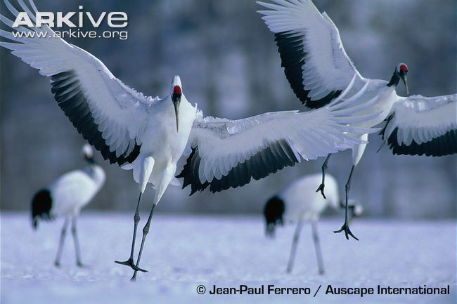 | Name: Japanese crane  Status:  Range:  Why am I threatened?
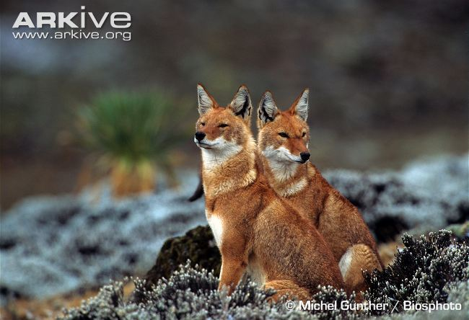 | Name: Ethiopian wolf  Status:  Range:  Why am I threatened?
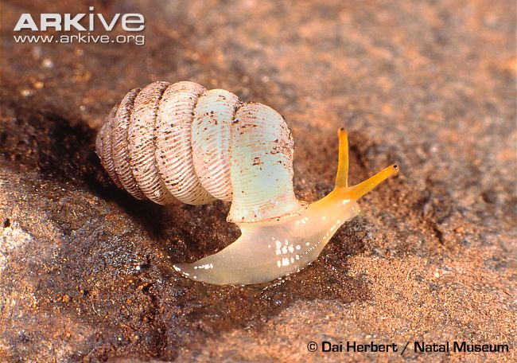 | Name: Trumpet-mouthed hunter snail  Status:  Range:  Why am I threatened?
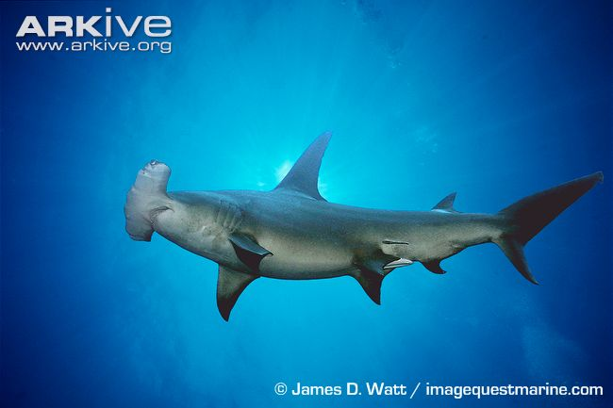 | Name: Great hammerhead  Status:  Range:  Why am I threatened?
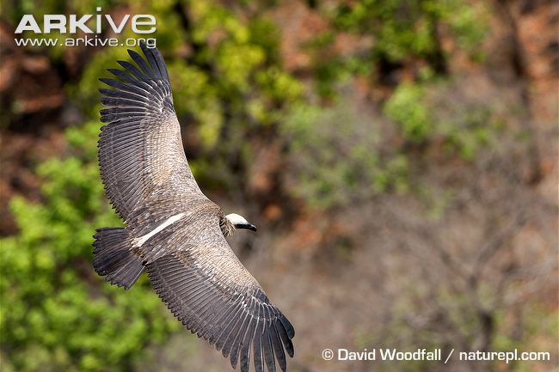 | Name: Asian white-backed vulture  Status:  Range:  Why am I threatened?
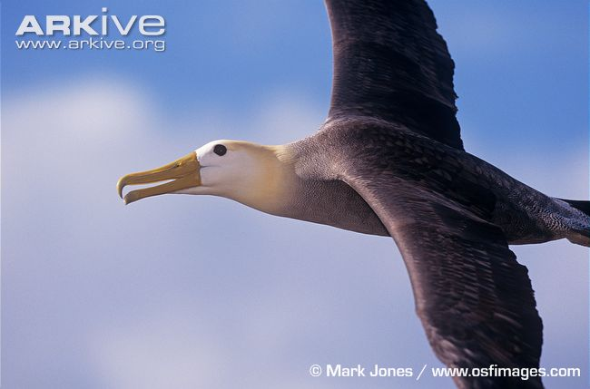 | Name: Waved albatross  Status:  Range:  Why am I threatened?
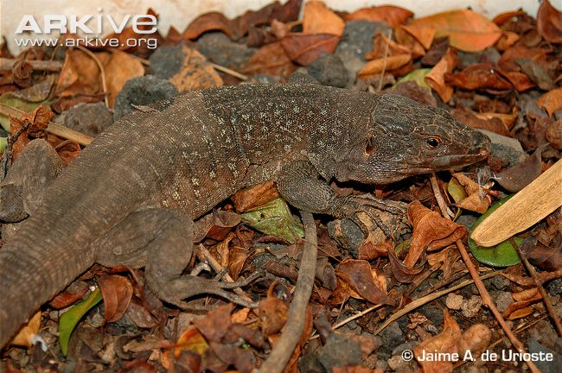 | Name: Tenerife speckled lizard  Status:  Range:  Why am I threatened?
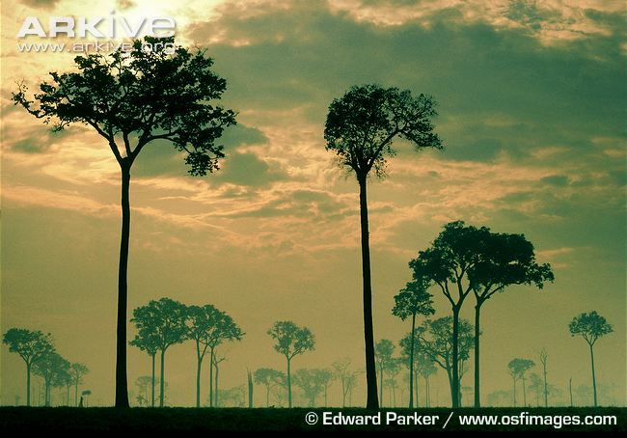 | Name: Brazil-nut tree  Status:  Range:  Why am I threatened?
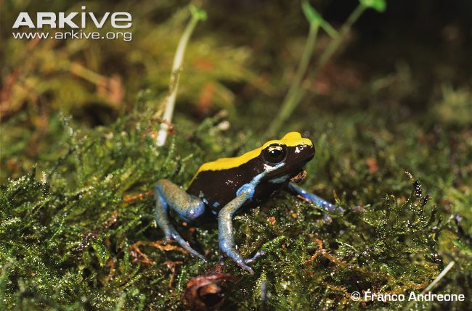 | Name: Blue-legged mantella  Status:  Range:  Why am I threatened?
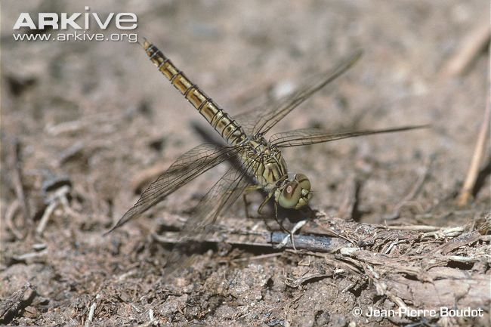 | Name: Dark-winged groundling  Status:  Range:  Why am I threatened?
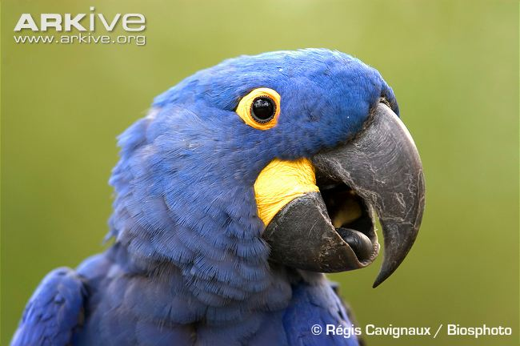 | Name: Hyacinth macaw  Status:  Range:  Why am I threatened?
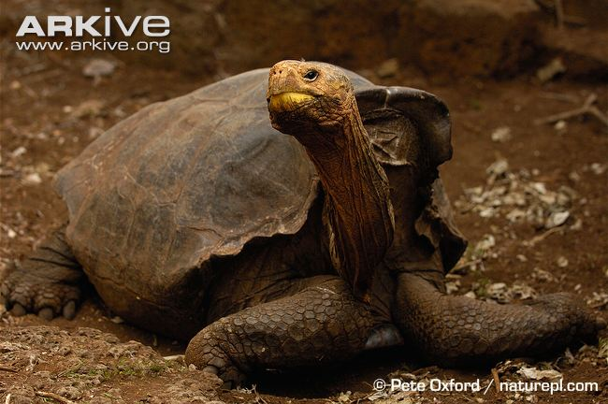 | Name: Galapagos giant tortoise (Hood Island species)  Status:  Range:  Why am I threatened?
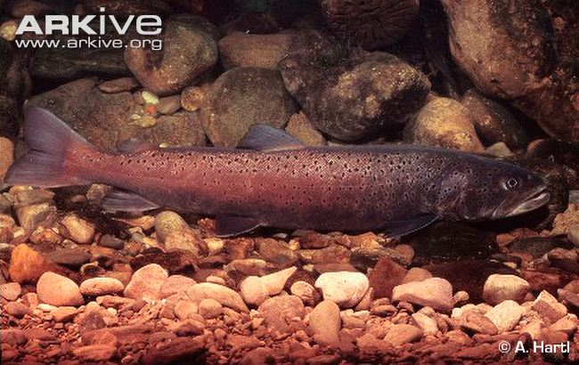 | Name: Danube salmon  Status:  Range:  Why am I threatened?
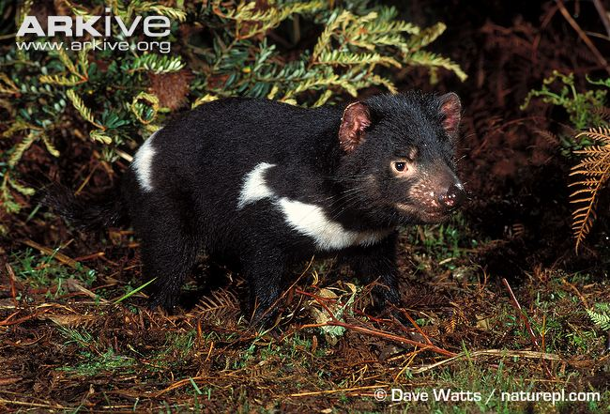 | Name: Tasmanian devil  Status:  Range:  Why am I threatened?
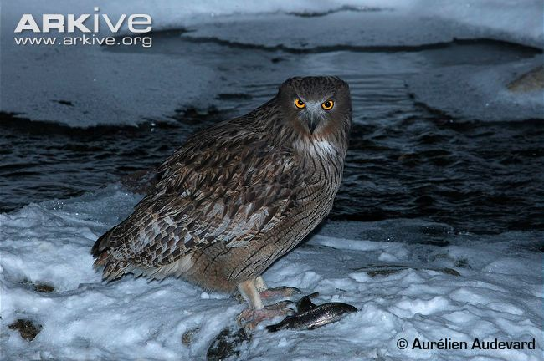 | Name: Blakiston’s fish owl  Status:  Range:  Why am I threatened?

