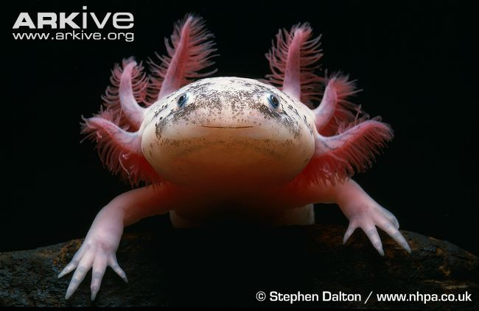 | Name: Axolotl  Status: Critically Endangered  Range: Mexico  Why am I threatened?  I live in lakes and canal systems around Mexico City so my biggest threat is pollution. As the city gets bigger more waste is being washed into the water and damaging my habitat.
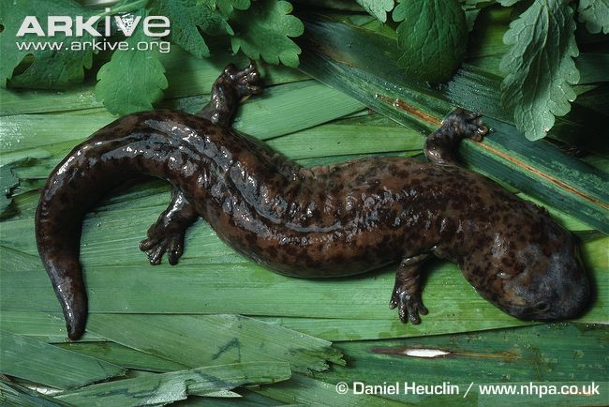 | Name: Chinese giant salamander  Status: Critically Endangered  Range: China  Why am I threatened?  The rivers I live in are becoming clogged with soil that is washed away when nearby trees are cut down. I am also hunted for food as I am considered a delicacy in Asia.
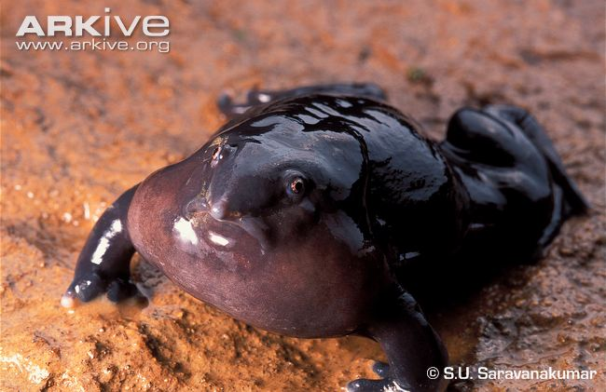 | Name: Purple frog  Status: Endangered  Range: India  Why am I threatened?  Much of my forest habitat is being destroyed to make way for farmland which humans use to grow coffee, ginger and other crops.
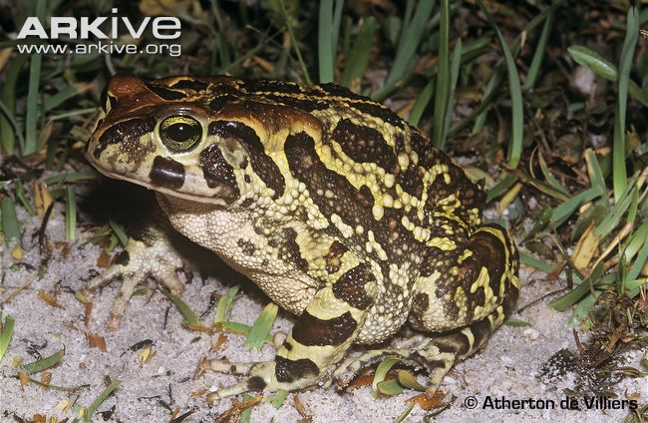 | Name: Western leopard toad  Status: Endangered  Range: South Africa  Why am I threatened?  I am found only in a small area of South Africa, so as humans build more roads and houses my habitat gets smaller and smaller.
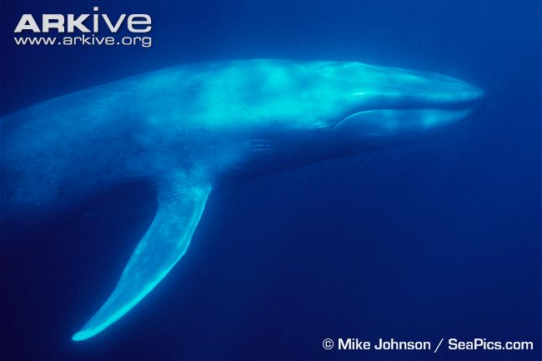 | Name: Blue whale  Status: Endangered  Range: Atlantic and Pacific Oceans  Why am I threatened?  Back in the 1900’s I was heavily hunted for my blubber, which was turned into oil and used for candle wax and fuel for lamps.
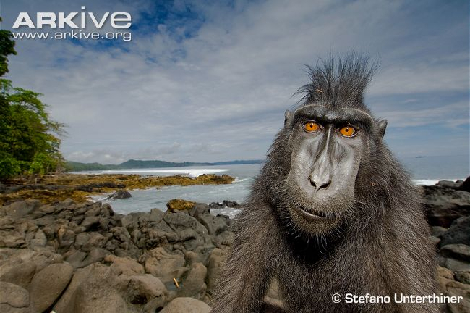 | Name: Crested black macaque  Status: Critically Endangered  Range: Indonesia  Why am I threatened?  Excessive hunting by humans for food is my biggest threat, as my meat is a delicacy in Sulawesi. My rainforest habitat is also being cleared so it can be converted to farmland.
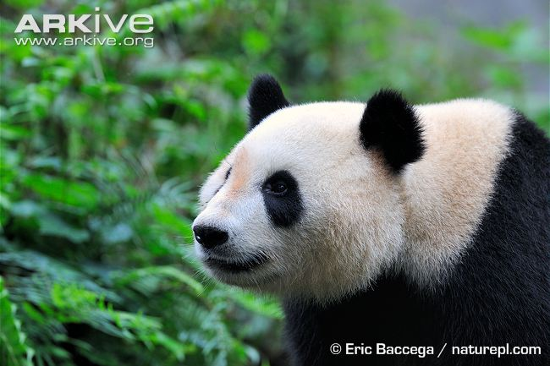 | Name: Giant panda  Status: Endangered  Range: China  Why am I threatened?  Large areas of my forest home have been cleared for farming, timber and firewood. As the human population grows my habitat gets smaller and smaller.
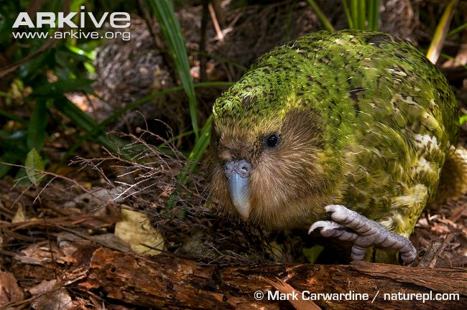 | Name: Kakapo  Status: Critically Endangered  Range: New Zealand  Why am I threatened?  I live on the ground and can’t fly which means I am easy to catch. I used to be hunted for my meat and feathers. Introduced animals such as dogs and rats also eat me.
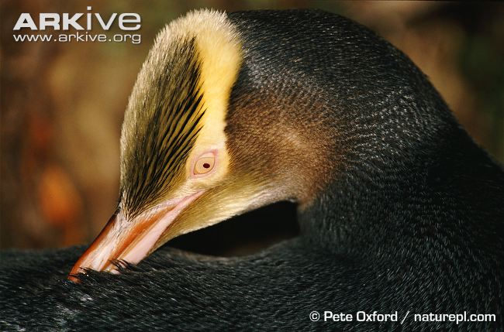 | Name: Yellow-eyed penguin  Status: Endangered  Range: New Zealand  Why am I threatened?  The coastal forests I live in are being removed to make way for buildings and farmland. My biggest problem is from introduced sheep and cattle because they trample my nest and squash my eggs.
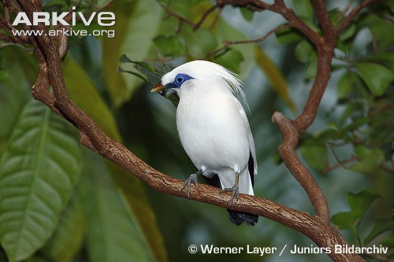 | Name: Bali starling  Status: Critically Endangered  Range: Indonesia  Why am I threatened?  I am very popular in the illegal wildlife trade, which means I am now very rare in the wild because too many birds have been captured to be kept as pets. The rarer my species becomes the more money people can sell me for on the black market.
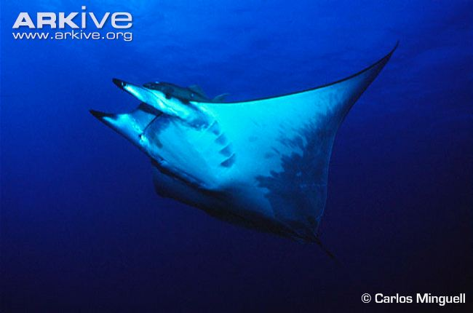 | Name: Giant devilray  Status: Critically Endangered  Range: Mediterranean Sea and Atlantic Ocean  Why am I threatened?  Overfishing of other fish species causes me problems because I sometimes get caught in nets accidentally by people trying to catch swordfish and tuna. This is known as bycatch.
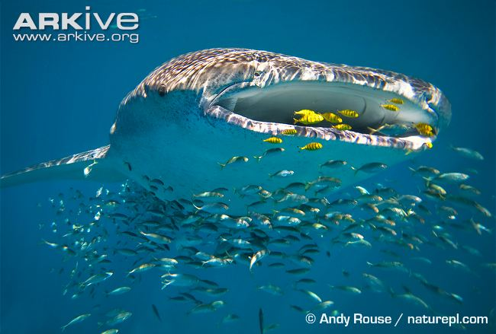 | Name: Whale shark  Status: Endangered  Range: Temperate & tropical waters worldwide  Why am I threatened?  My biggest threat is overfishing, as my flesh is worth a lot of money in Asia. Shark fin soup has also become very popular so I am sometimes caught just for my fin – but I can’t survive without it.
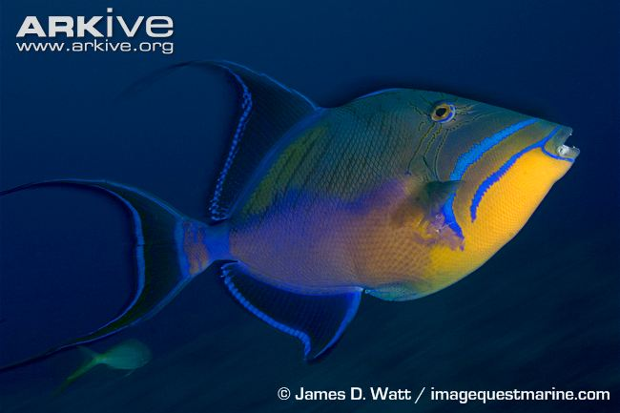 | Name: Queen triggerfish  Status: Vulnerable  Range: Atlantic Ocean  Why am I threatened?  I am a popular fish for humans to eat, so people catch me using spears and traps in my coral reef habitat. This often leads to overfishing.
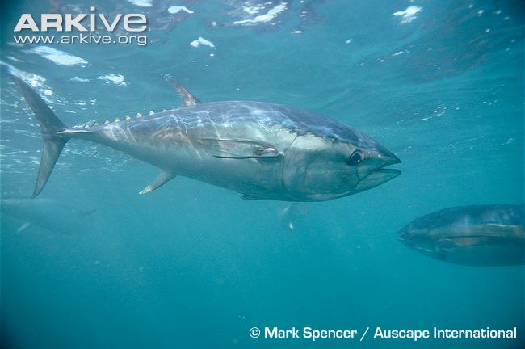 | Name: Southern bluefin tuna  Status: Critically Endangered  Range: Southern Oceans  Why am I threatened?  Using different methods, people have fished me to the brink of extinction as I am a popular food, particularly in Japan where I am worth lots of money.
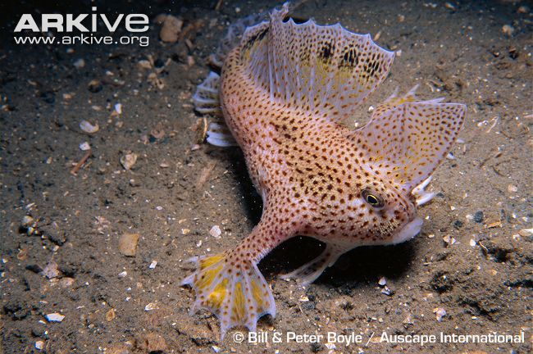 | Name: Spotted handfish  Status: Critically Endangered  Range: Tasmania, Australia  Why am I threatened?  My biggest threat comes from an invasive species. The introduction of the northern Pacific seastar has created a big threat to my survival, as they like to eat my eggs.

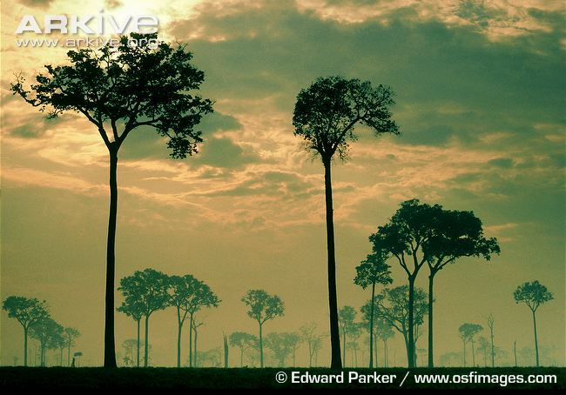 | Name: Brazil-nut tree  Status: Vulnerable  Range: South America  Why am I threatened?  My seeds are very valuable so they are collected by humans, but they have been over-harvested so there are not many left in the wild to grow into young trees.
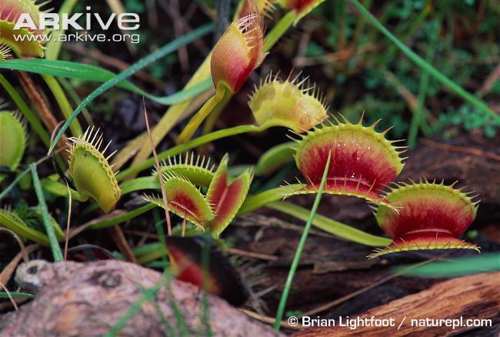 | Name: Venus flytrap  Status: Vulnerable  Range: USA  Why am I threatened?  Because I am such a fascinating carnivorous plant, people like to collect me. This means illegal collection from the wild for the wildlife trade is the biggest threat to my survival.
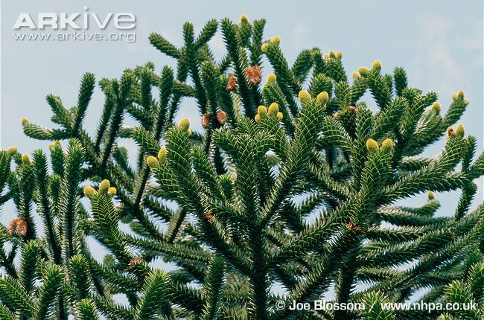 | Name: Monkey puzzle  Status: Endangered  Range: Chile & Argentina, South America  Why am I threatened?  My wood is commonly harvested for construction, shipping and furniture as it is strong and disease resistant. General habitat destruction and the spread of forest fires have also destroyed large parts of my home.
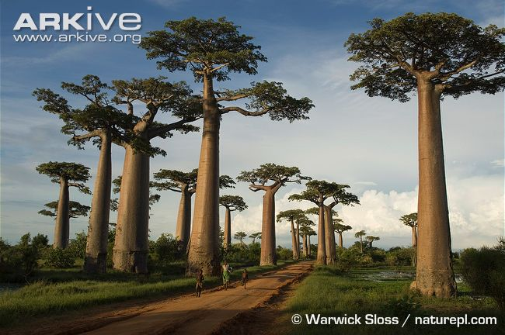 | Name: Grandidier’s baobab  Status: Endangered  Range: Madagascar  Why am I threatened?  Much of my forest habitat is being cleared for use as farmland. This is reducing the number of young trees, so when the old ones die there will be very few trees left.
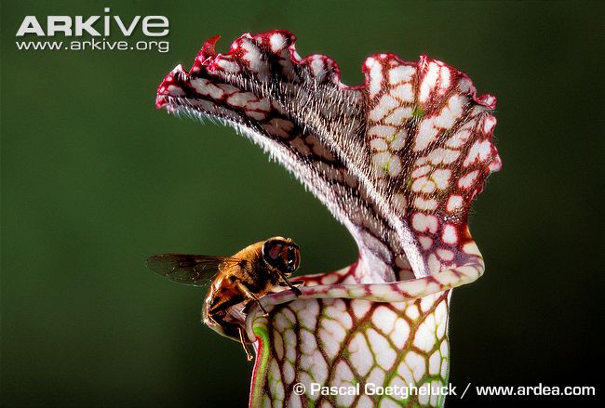 | Name: White-topped pitcher plant  Status: Endangered  Range: USA  Why am I threatened?  I am very popular with collectors because I am colourful and carnivorous (I eat insects!), so over-collection for the wildlife trade is a problem. My wetland habitat is also being drained so the land can be used to build on.
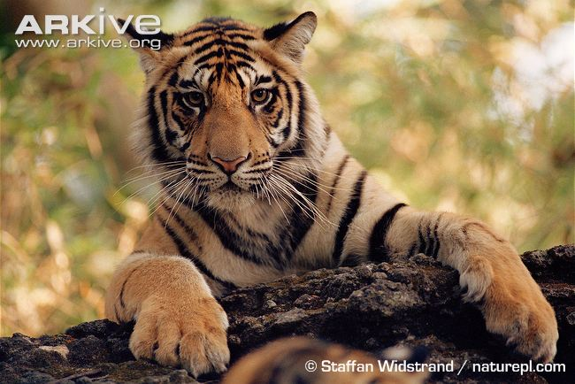 | Name: Tiger  Status: Endangered  Range: India and Southeast Asia  Why am I threatened?  I have been hunted for sport in the past, but now poaching for use in oriental medicine and farmers illegally hunting me are my biggest threats.
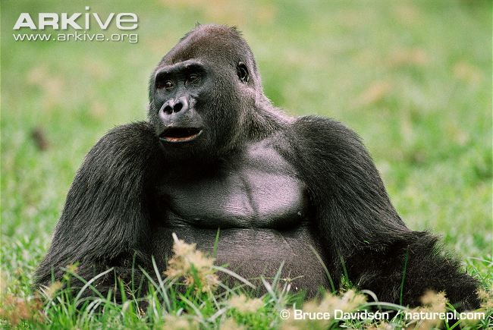 | Name: Western gorilla  Status: Critically Endangered  Range: Western Africa  Why am I threatened?  One of my biggest threats is the spread of the deadly Ebola virus. My forest habitat is also being destroyed to make way for logging and farmland which makes it easier for hunters to get into the forest and catch me for the bushmeat trade.
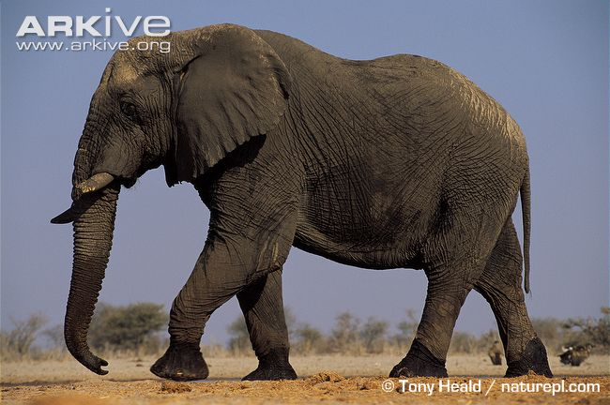 | Name: African elephant  Status: Vulnerable  Range: Parts of Africa  Why am I threatened?  I have historically been hunted for my tusks, which are sold as ivory. I also sometimes come into conflict with humans as much of my range has now been converted to farmland.
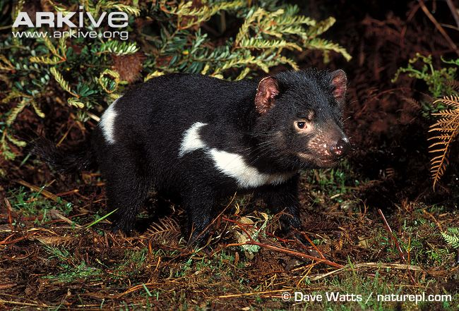 | Name: Tasmanian devil  Status: Endangered  Range: Tasmania, Australia  Why am I threatened?  I used to be considered a pest so was trapped and killed by farmers. More recently, a deadly disease has become my biggest threat.
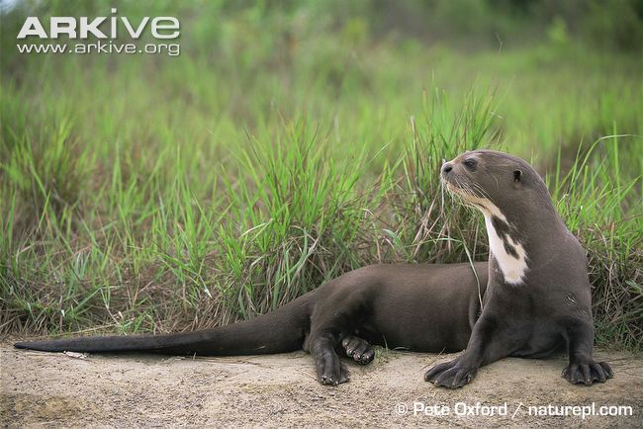 | Name: Giant otter  Status: Endangered  Range: South America  Why am I threatened?  I used to be hunted for my fur, but now habitat loss and pollution are my major threats because my habitat is being destroyed by mining and logging.
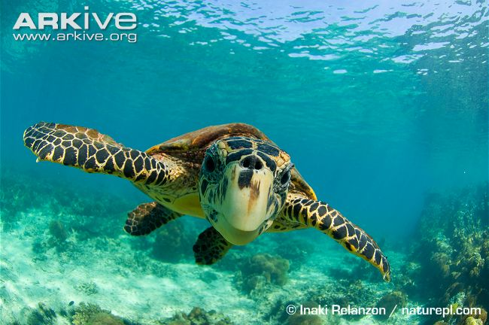 | Name: Hawksbill turtle  Status: Critically Endangered  Range: Found worldwide in tropical waters  Why am I threatened?  I am illegally hunted for my shell, which can be sold and used in jewellery. Other threats include climate change, hunting for meat and collection of my eggs.
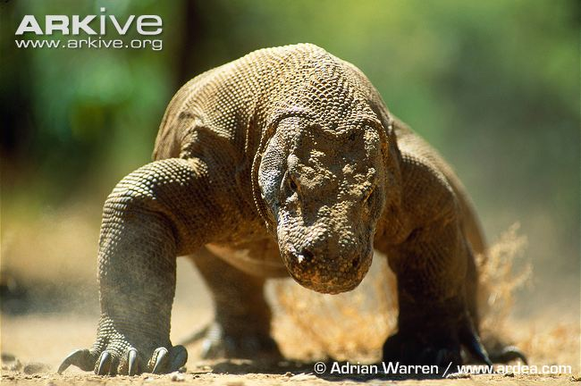 | Name: Komodo dragon  Status: Vulnerable  Range: Komodo Island, Indonesia  Why am I threatened?  Habitat loss is my biggest threat, but hunting is also causing me problems. Humans are hunting deer which are my prey, so there is not enough food left for me.
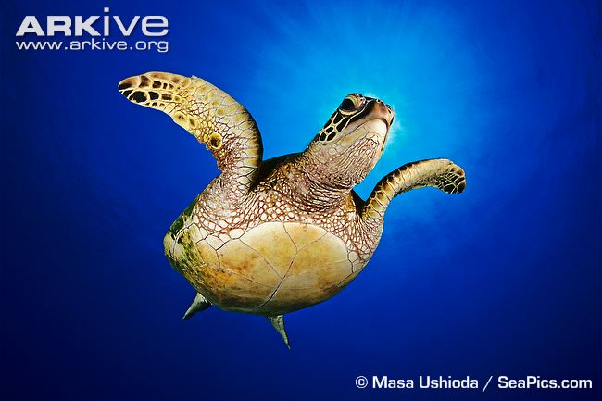 | Name: Green turtle  Status: Endangered  Range: Pacific, Atlantic and Indian Oceans  Why am I threatened?  My major threat comes from being harvested for my meat and eggs. I am often also accidentally caught by fisherman when I get tangled in their nets.
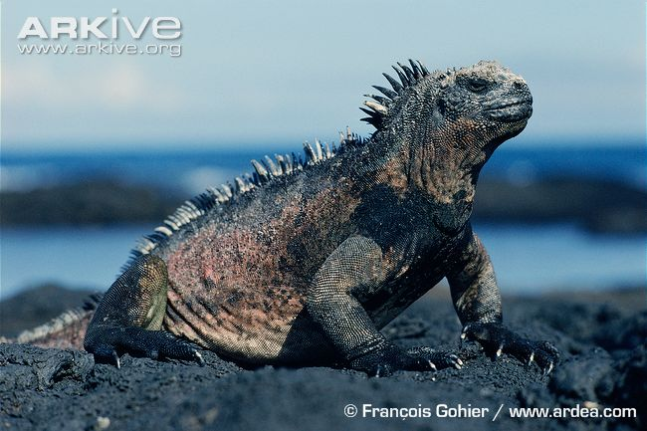 | Name: Galapagos marine iguana  Status: Vulnerable  Range: Galapagos Islands  Why am I threatened?  My biggest threat is from introduced animals such as cats, dogs and rats which kill me and eat my eggs. Pollution is also a big problem as it damages my food supply and nesting area.
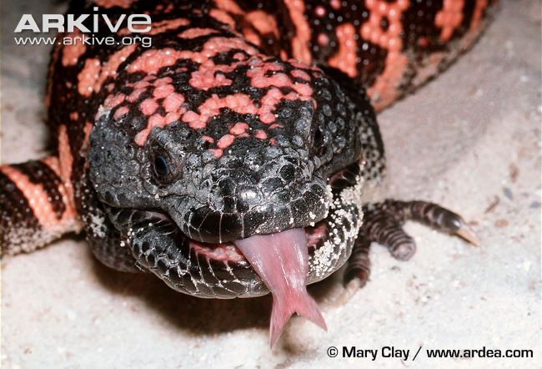 | Name: Gila monster  Status: Near Threatened  Range: USA  Why am I threatened?  Much of my bushland habitat has been destroyed by urban development and roads. I am also often killed by domestic dogs and cats which have been introduced into my habitat by humans.
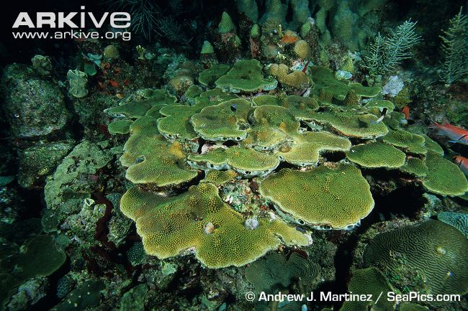 | Name: Boulder star coral  Status: Endangered  Range: Caribbean Sea, Western Atlantic  Why am I threatened?  Pollution because of human activity is one of the biggest threats to my survival. The temperature of the sea is also rising and this causes me problems because I can’t survive when the water gets warmer.
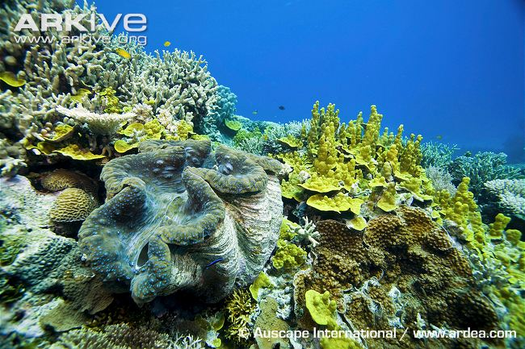 | Name: Giant clam  Status: Vulnerable  Range: Pacific Ocean  Why am I threatened?  I am harvested for meat as food, and also for aquarium collections because I am such an impressive size and exotic colour.
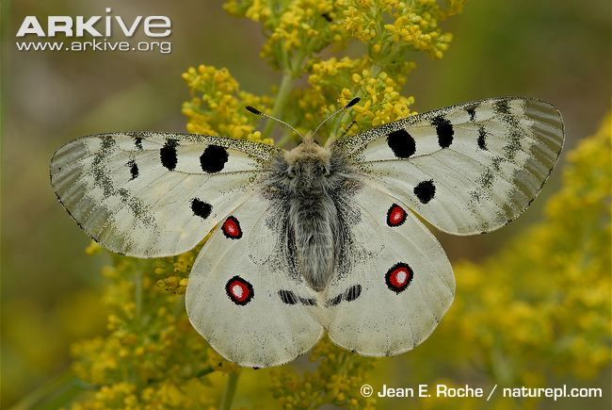 | Name: Apollo butterfly  Status: Vulnerable  Range: Europe  Why am I threatened?  My lovely wing patterns mean people want to collect me, but because of over-collection I am now very rare in the wild. Also, lots of my habitat has been changed into farmland and buildings.
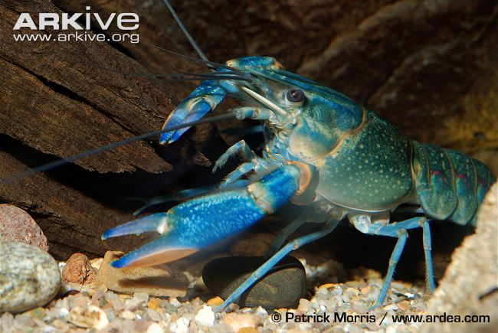 | Name: Yabbie crayfish  Status: Vulnerable  Range: Australia  Why am I threatened?  Lots of my swampy habitat is surrounded by farmland and the chemicals they use on the land get into the water where I live. Competition from invasive species is also a threat to my survival.
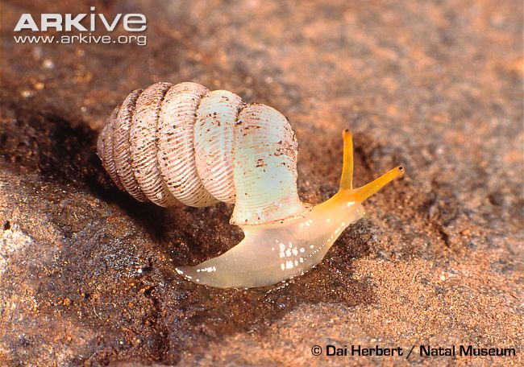 | Name: Trumpet-mouthed hunter snail  Status: Critically Endangered  Range: South Africa  Why am I threatened?  I am only found in one very small area of South Africa, but this area is currently being mined for marble, which means that habitat loss is the biggest threat to my survival.
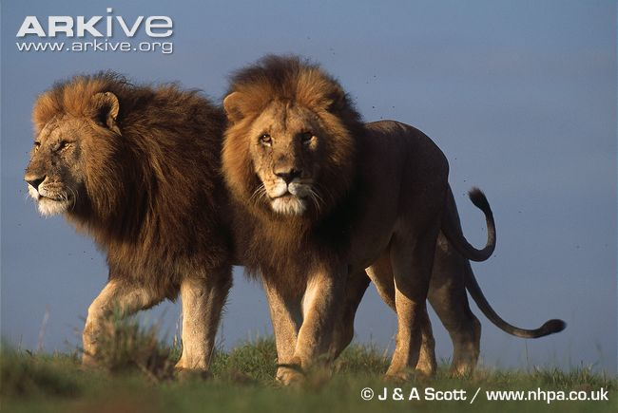 | Name: Lion  Status: Vulnerable  Range: Sub-Saharan Africa and India  Why am I threatened?  I used to be killed for sport, but now I have other problems. There aren’t as many of the wild animals around that I like to eat, because my habitat is being turned into farmland, so I sometimes steal a cow which upsets the farmers and they shoot at me.
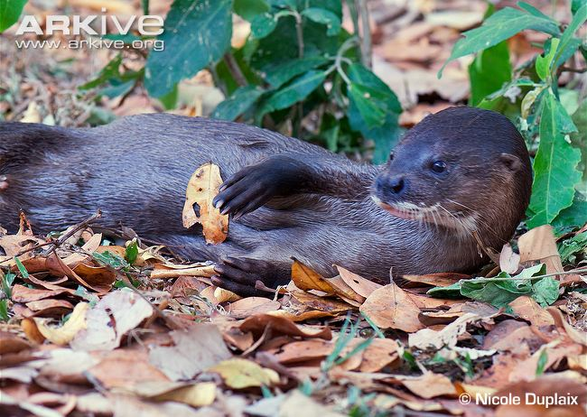 | Name: Hairy-nosed otter  Status: Endangered  Range: Parts of Southeast Asia  Why am I threatened?  The illegal wildlife trade is my biggest threat, hunters catch me then sell my fur because it is worth lots of money. Also, the peat bogs where I live are being converted to farmland and rice paddies to grow food for humans.
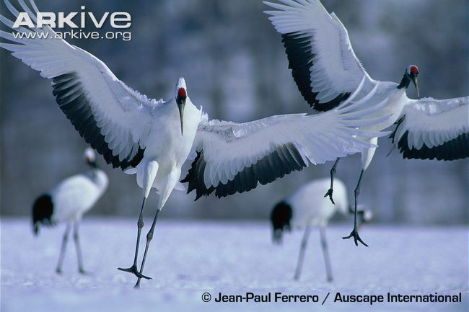 | Name: Japanese crane  Status: Endangered  Range: Japan, China, Russia and Mongolia  Why am I threatened?  I was almost hunted to extinction for my beautiful feathers which humans use for decoration. Now my biggest threat is the loss of my wetland habitat, as it is being converted into farmland and building land for human development.
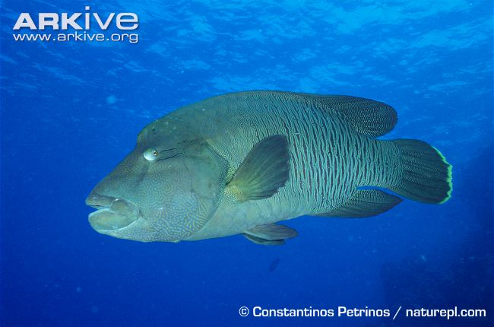 | Name: Humphead wrasse  Status: Endangered  Range: Indian and Pacific Oceans  Why am I threatened?  I am caught for food as my meat is a delicacy in Asian countries, particularly Hong Kong. The fishermen that catch me use a poison that damages me as well as the coral reef where I live, killing other fish that live there too.
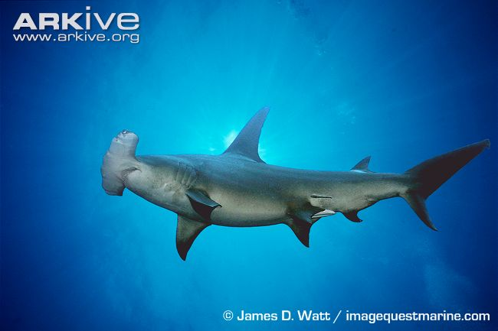 | Name: Great hammerhead  Status: Endangered  Range: Atlantic, Pacific and Indian Oceans  Why am I threatened?  My fins are very valuable and can be made into shark fin soup which is very popular in Asia, so my biggest threat is overfishing. Fishermen also catch me accidentally sometimes when they are catching other fish and I get tangled in their nets.
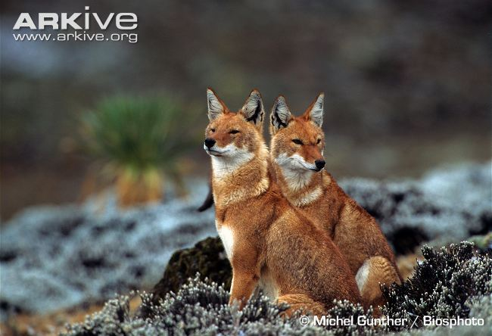 | Name: Ethiopian wolf  Status: Endangered  Range: Ethiopia  Why am I threatened?  Much of my habitat high in the Ethiopian mountains is being turned into farmland, so humans are moving up into the mountains and bringing their dogs too. The diseases carried by domestic dogs, such as rabies, are very dangerous to me and are the biggest threat to my survival.
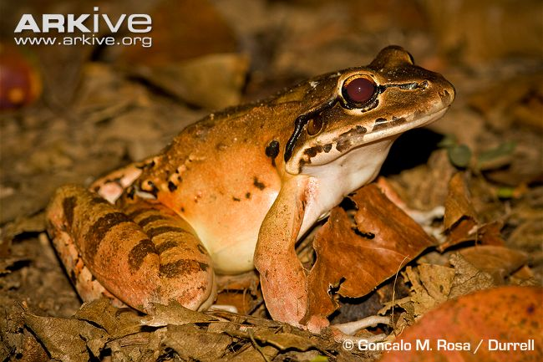 | Name: Mountain chicken  Status: Critically Endangered  Range: Caribbean Islands (Dominica & Montserrat)  Why am I threatened?  I am harvested for food as people like to eat my meaty legs, and parts of my habitat are being destroyed to make way for human settlements. My biggest threat is a deadly fungal disease that is wiping out populations of frogs worldwide.
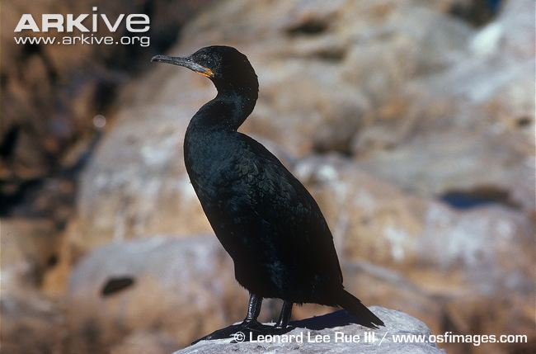 | Name: Cape cormorant  Status: Near Threatened  Range: Southern Africa  Why am I threatened?  There are a number of threats to my survival including overfishing of on of my favourite fish, the South African pilchard. One of my biggest threats is a deadly disease called avian cholera.
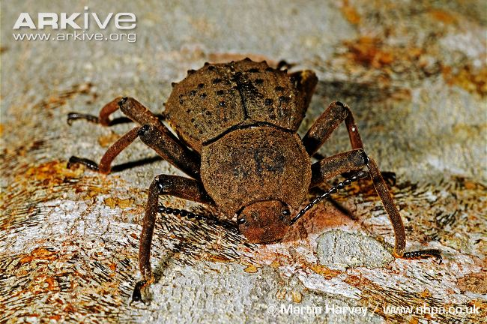 | Name: Frigate Island giant tenebrionid beetle  Status: Critically Endangered  Range: Seychelles  Why am I threatened?  I am only found on one small island in the Seychelles and feed on a single tree. My biggest threat is a fungal disease that is killing these trees which means I have less food to eat.
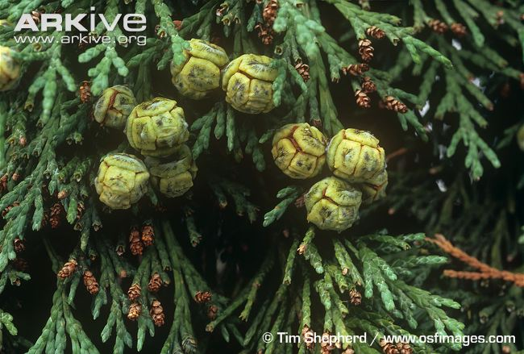 | Name: Lawson’s cypress  Status: Vulnerable  Range:, USA  Why am I threatened?  My wood is very valuable so I was originally threatened by logging. Now a nasty disease called root rot is causing me lots of problems and is killing lots of trees.
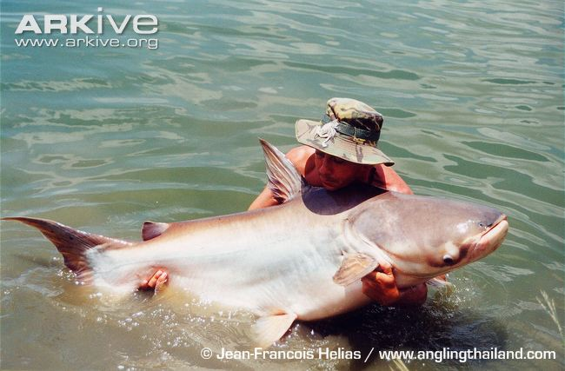 | Name: Giant catfish  Status: Critically Endangered  Range: Mekong River basin, Asia  Why am I threatened?  I am the world’s largest freshwater fish so am very popular with fishermen as I provide a lot of food. Overfishing for food is my biggest threat but my habitat is also being destroyed, which disrupts my migration up the river to lay my eggs.
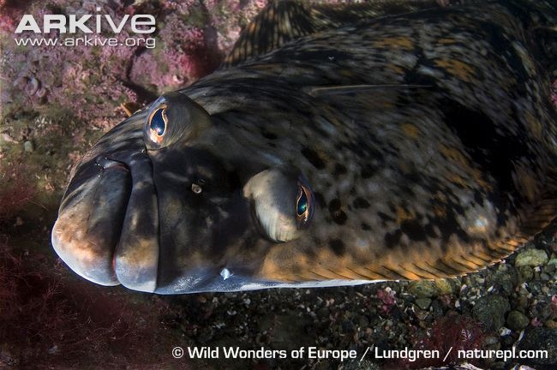 | Name: Atlantic halibut  Status: Endangered  Range: Northern Atlantic  Why am I threatened?  I am a very popular food fish so I have been over-fished for many years, hugely reducing my numbers in the wild.
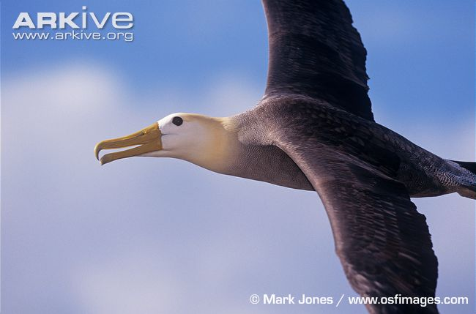 | Name: Waved albatross  Status: Critically Endangered  Range: Galapagos  Why am I threatened?  Human fishing activities are my biggest threat because I try to eat the bait on the fishing lines and end up getting caught on the hooks and tangled in the lines. The more fishing there is taking place, the higher the chances I will get tangled.
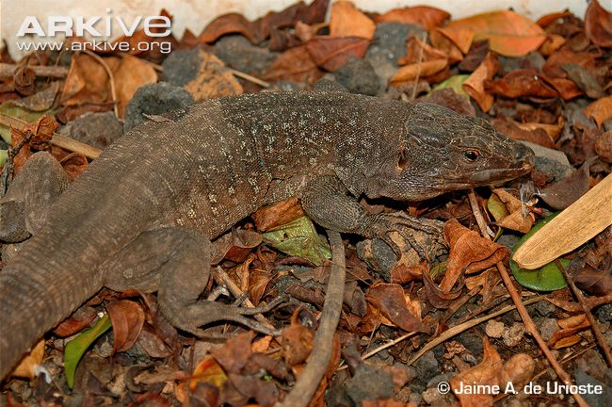 | Name: Tenerife speckled lizard  Status: Critically Endangered  Range: Tenerife  Why am I threatened?  I am a very rare lizard found only along a very small section of the coast of Tenerife. When humans came to the island they brought cats with them which have now become widespread and are a threat to my survival because they like to eat me!
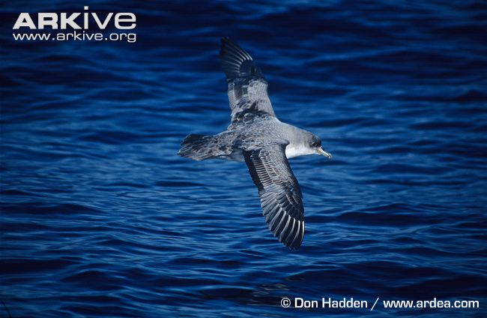 | Name: Grey petrel  Status: Near Threatened  Range: Islands near the Antarctic  Why am I threatened?  I nest on the ground which means invasive species such as cats and rats are a big problem as they eat my eggs and chicks. Overfishing is also a huge problem as I get caught on fishing lines because I like eating the food scraps around fishing boats.
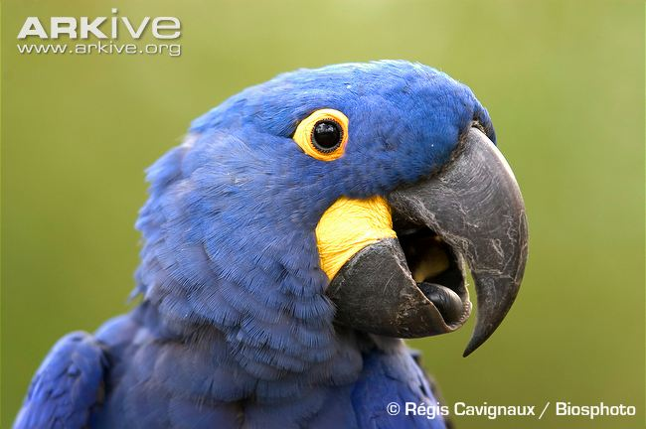 | Name: Hyacinth macaw  Status: Endangered  Range: Brazil, South America  Why am I threatened?  My main problem is collection for the illegal wildlife trade, which has taken place for many years. This means my population in the wild is getting smaller. Also, much of my habitat is being converted to farmland for cattle to graze.
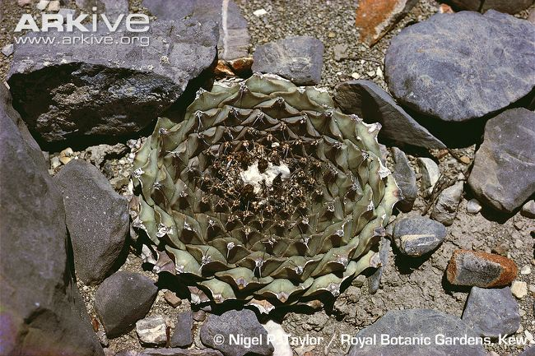 | Name: Artichoke cactus  Status: Vulnerable  Range: Mexico  Why am I threatened?  During the summer I have amazing flowers which means I am collected in large numbers for the commercial wildlife trade. Local people also collect me to use in traditional medicines.
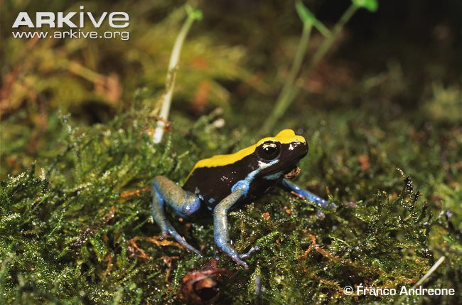 | Name: Blue-legged mantella  Status: Critically Endangered  Range: Madagascar  Why am I threatened?  I have such beautifully coloured markings that I am very popular as a pet, but this over-collection for wildlife trade is reducing my numbers in the wild and is the biggest threat to my survival.
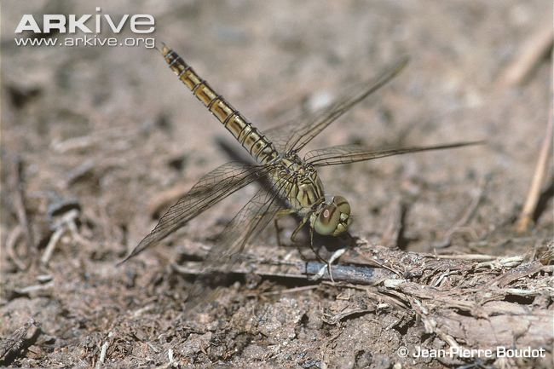 | Name: Dark-winged groundling  Status: Vulnerable  Range: Turkey and Iran  Why am I threatened?  I live by pools and slow-moving streams but the water is becoming polluted with pesticides which is threatening my survival.
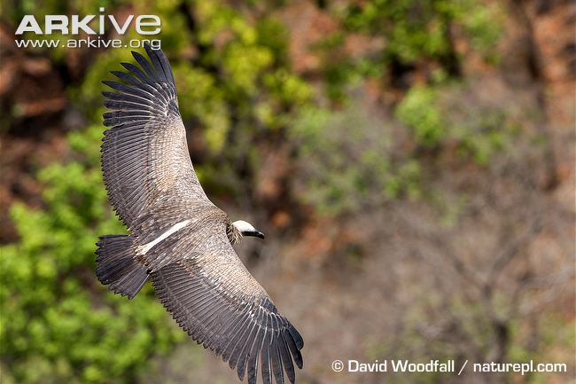 | Name: Asian white-backed vulture  Status: Critically Endangered  Range: Southern Asia  Why am I threatened?  I used to be hunted and captured for the wildlife trade, but these days I have a bigger problem as my food source is polluted. Many of the cattle I feed on have been treated with a drug that poisons me.
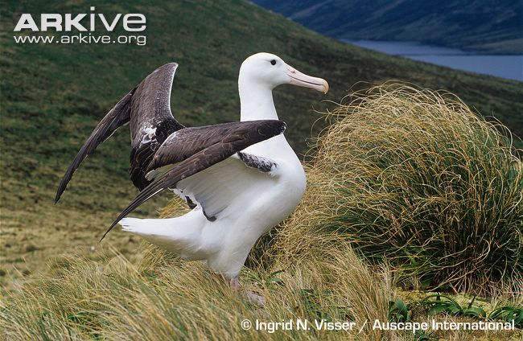 | Name: Southern royal albatross  Status: Vulnerable  Range: New Zealand (small islands off the coast)  Why am I threatened?  I build my nest on the ground which was fine when no ground predators lived on my islands. Pigs and cats were recently introduced and have become my biggest threat because they eat my eggs and chicks.
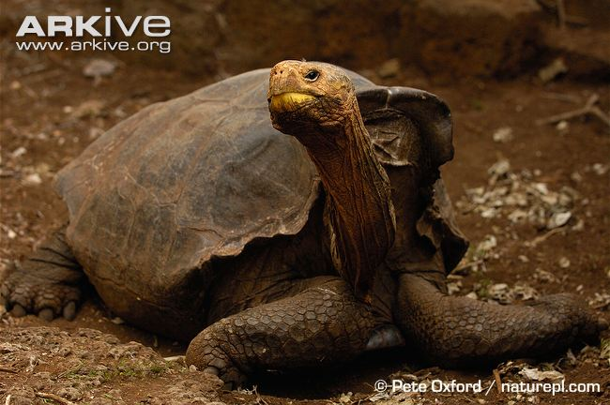 | Name: Galapagos giant tortoise  (Hood Island species)  Status: Critically Endangered  Range: Galapagos Islands  Why am I threatened?  Goats and cattle compete with me for food while dogs, cats and rats feed on juvenile giant tortoises, so invasive species introduced to the Galapagos are definitely my biggest threat.
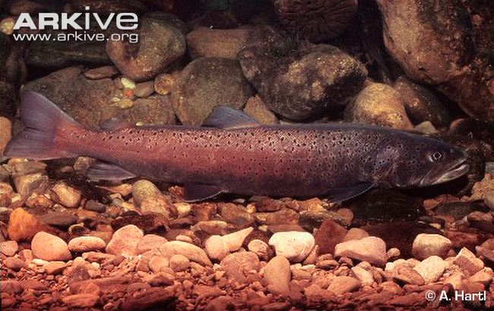 | Name: Danube salmon  Status: Endangered  Range: Danube River basin, Europe  Why am I threatened?  Many of the rivers that I live in are becoming polluted with industrial and agricultural waste, which means chemicals get washed from the land into my rivers. Because of this I am now one of the rarest fish in Europe.
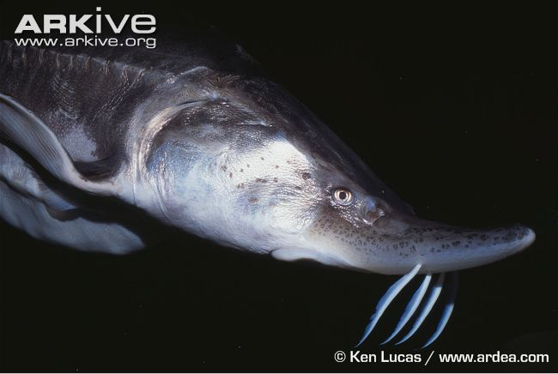 | Name: Beluga  Status: Critically Endangered  Range: Europe, Caspian Sea  Why am I threatened?  My eggs are very popular with humans, who call them caviar and like to eat them. They are actually the most expensive eggs of any fish which means humans catch me so they can sell my eggs.
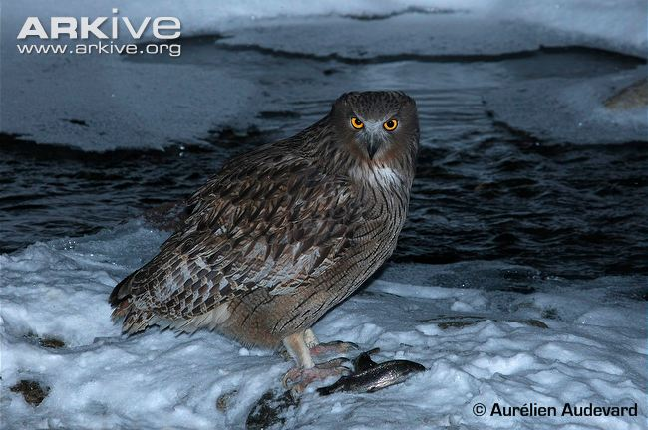 | Name: Blakiston’s fish owl  Status: Endangered  Range: Siberia, China & Japan  Why am I threatened?  I am a large bird of prey and am specialised to feed on creatures that live in water, particularly fish. Overfishing by humans is making it harder for me to find enough fish to eat.

