What to do today

1. Listen to a story
Listen on here https://youtu.be/Bbuv2gvjUqM to the reading of The Sword in the Stone.
- Does this remind you of any other stories that you have seen or read? How do you think Arthur felt when he realised what he had done?

2. Read the story and answer some questions
- Read the The Sword in the Stone.
- Read the Sword in the Stone Questions. Think carefully about each of these questions. Write your answers in clear sentences.

Well done! Now show a grown-up your answers to the questions. Can you tell them the story?

3. Make a Character Map
- Draw pictures of each of the five characters from this story. You could use Character Pictures to give you ideas.
- Write notes about what you know about each of the characters around your pictures. Use lines and arrows to show how the characters are connected to each other (e.g. Kay is Ector’s son)

Try these Fun-Time Extras
- Can you make a picture of Arthur lifting the sword from the stone in front of Merlin, Ector, Kay and the other knights? Use speech-bubbles and thought-bubbles to show what all the characters are saying and thinking.

The Sword in the Stone

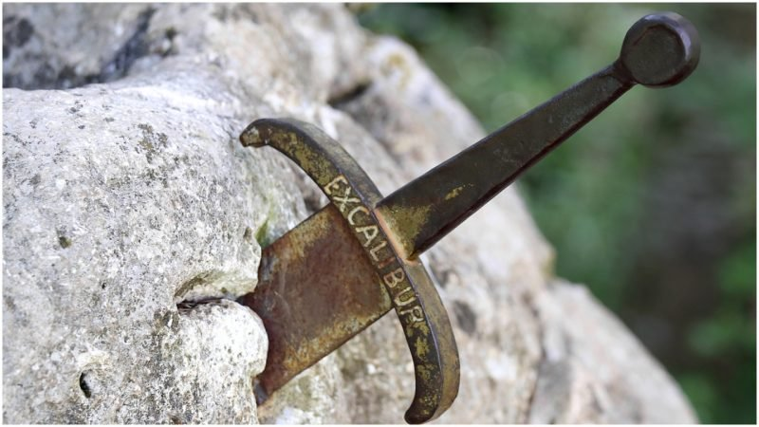

This legend starts with Uther Pendragon, king of Southern Britain. At that time there was a lot of fighting. In Uther’s kingdom there was peace.

Merlin was a magician who could change himself into an animal or bird. One day he went to the king and told him he would have a son. His son would be a great man.
“In two years you will be dead. If anyone knows about your son the child will be killed in the struggle for the throne. When he is born you must give him to me to hide,” said Merlin.
When Arthur was born, Merlin took the child and gave him to Sir Ector and his son Kay to look after. He did not tell them who Arthur really was.

Everything happened as Merlin said. Soon the knights were fighting about who would become king. When Arthur was about 16 years old, Merlin went to see the Archbishop of London and told him the true born king of England would soon be found. While some knights were in the cathedral a crash was heard. When they went outside they saw a stone. In the stone was a sword and on the stone it said,
WHOEVER PULLS THE SWORD FROM THE STONE
WILL BE THE RIGHTFUL KING OF ALL BRITAIN
Each knight tried to pull the sword from the stone. It was stuck. The archbishop called all the knights in Britain to a tournament on New Year’s Day. They were going to show how well they could fight. They were going to try and pull the sword from the stone.

Sir Ector and Kay were on the way to the tournament when Kay remembered he had left his sword at the inn. He spoke to Arthur, who was now his squire.
“Go and get my sword,” he said.
The inn was locked but Arthur saw the sword in the stone.
“I’ll take that sword,” he said and pulled it out and then gave it to Kay.
“Where did that sword come from?” said Sir Ector and Arthur explained what had happened.
“You are my king,” said Sir Ector to Arthur. Arthur did not understand so Sir Ector told him all about Merlin.

The other knights did not believe that Arthur was king. Merlin put the sword back in the stone. All the knights tried again but were still unable to move the sword. Once again, Arthur pulled it out easily. Everybody knew that Arthur was the rightful king, son of Uther Pendragon.

Questions: Sword in the Stone

- Where is the legend about King Arthur set?
- What was England like during King Uther’s reign?
- Who was Merlin?
- Why did Merlin take Arthur from Uther as soon as he was born?
- How do you think Arthur’s mother (Queen Igraine) and Uther felt about this?
- Why did Arthur first try to pull the sword from the stone?
- How did Merlin convince the other knights that Arthur was the rightful king of England?
- How do you think Arthur felt when all the knights agreed that Arthur was the true king?

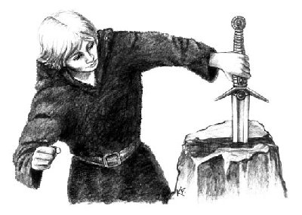

Character Pictures

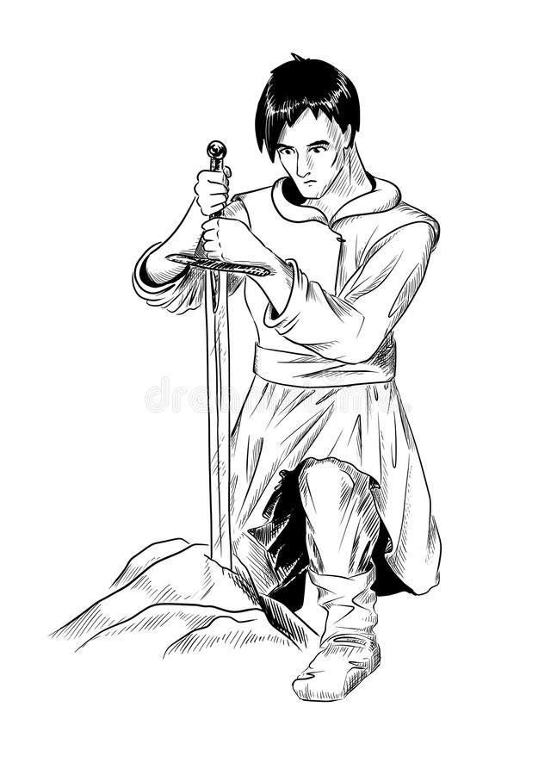 |  | 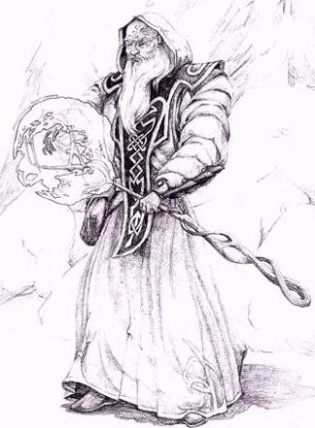
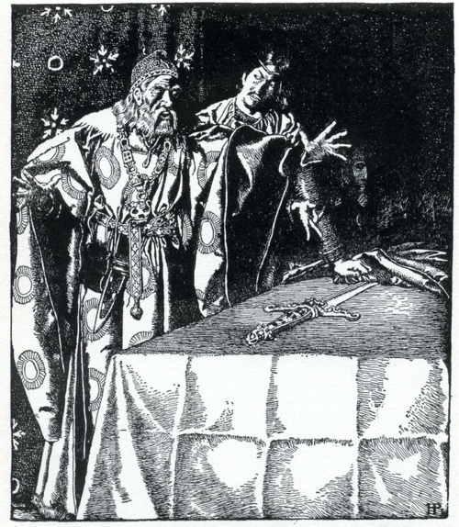 | 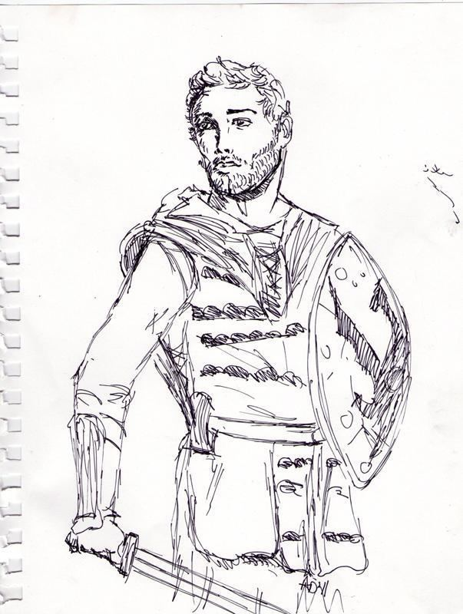 |  | 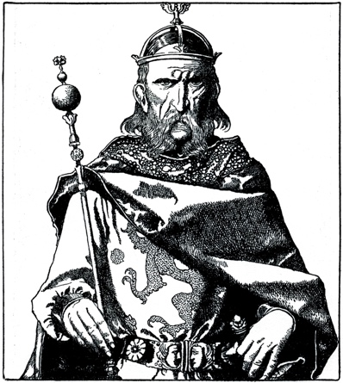

from left to right – top: Arthur, Merlin – bottom: Ector, Kay, Uther Pendragon
Character Map

Draw the characters. Write notes about what you know about them and draw arrows to show how they relate to each other.
Possible Answers Questions: Sword in the Stone

- Where is the legend about King Arthur set?
It is set in southern Britain.
- What was England like during King Uther’s reign?
There was a lot of fighting but in Uther’s kingdom there was peace.
- Who was Merlin? Merlin was a magician.
- Why did Merlin take Arthur from Uther as soon as he was born? Merlin took Arthur to protect him. He knew that Uther would die in a couple of years and that there would be fighting about who become king. He realised that Arthur might be killed in the struggle for the throne.
- How do you think Arthur’s mother (Queen Igraine) and Uther felt about this? Answers will vary but children should try to explain their answers, e.g. I think Igraine and Uther would be really upset because they would miss their baby son a lot.
- Why did Arthur first try to pull the sword from the stone? To give it to Sir Kay to use in the tournament because they had forgotten to bring his sword.
- How did Merlin convince the other knights that Arthur was the rightful king of England? Merlin put the sword back in the stone, the other knights still couldn’t pull it out but when Arthur tried again he could.
- How do you think Arthur felt when all the knights agreed that Arthur was the true king? Answers will vary but children should try to explain what they think, e.g. I think Arthur would have been very confused because he didn’t know his real father had been a king.

