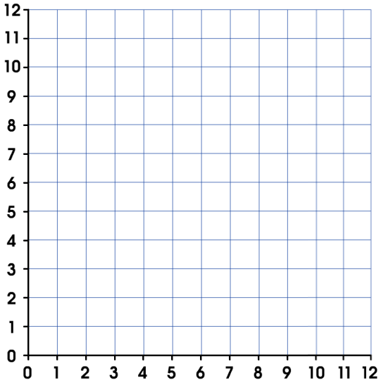
Right 6, Up 6
LO To translate shapes – write the translation that has happened to the shape. The first one has been done for you.
A
B
A
B
A
B
A
B
A
A
B
B

