
Dobcroft Junior`s Fitness Training
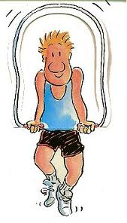


Pupil Record Card
Name _______________________________ Class _____________
Date
- Step Ups
- Push Ups
- Sit Ups
- Squats
- Star Jumps
Total Score

How many can you complete in 45 seconds?
Try and complete this as many times as you can throughout the week and see if you can improve your scores every day! I know you can ☺

