Y5 Wider Curriculum – Music
Week beginning 08.02.21

Task 1
LO: To appreciate and classify Chinese Instruments
Next week marks the start of the Chinese New Year. Take a look at the Powerpoint and then move on to Task 2!

Task 2
You’re going to compose a 4 bar composition for a Chinese fan dance (which we will do in our next lesson!). When you have finished and if yo’d like to, upload a video clip of your final piece onto Class Dojo (video it so that it plays twice through). Let’s start!
Go onto Chrome Music Lab, Song-Maker section:
https://musiclab.chromeexperiments.com/Song-Maker/

Go to settings (bottom right) and change the scale to pentatonic:
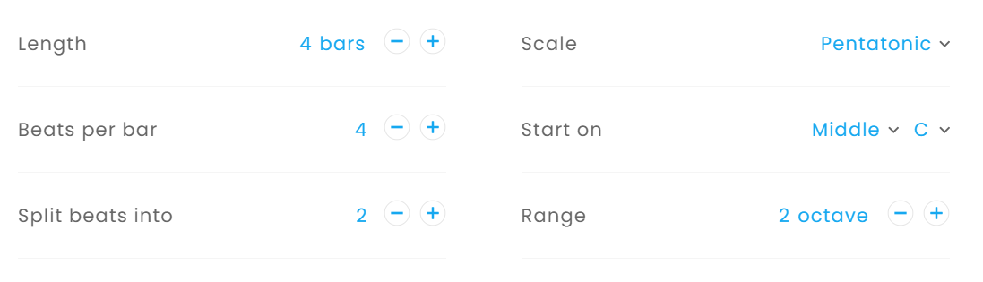

Change the tempo (speed) to somewhere between 70 and 100. It doesn’t want to be too fast because the fan dance will be slow and graceful.
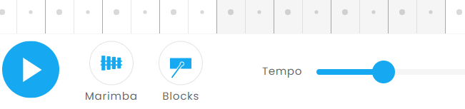

You can change the instruments (bottom left) too; the one on the right controls the pulse (beat). In the following screen shot, I have added the beat in for half of the section ….. would you continue to add the beats? Change the pulse and see what effect you like; perhaps start by adding in a beat at the start of every bar (I have put the circles are at the start of a bar, and the triangles are on the 2nd half of the beat), then experiment by removing some – what effect has this had?
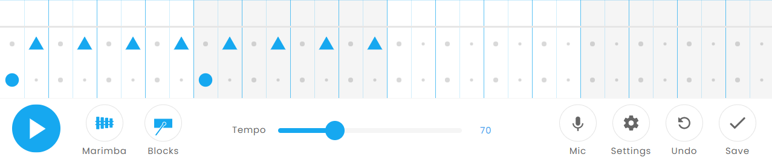
Pulse
Click this to change the instrument that plays the pulse.

Click this to change the instrument that plays the melody.

Chinese music is often written around a pentatonic scale (pentatonic uses 5 notes from an octave range). You’re going to compose using a major pentatonic scale’s 5 notes; 1st, 2nd, 3rd, 5th and 6th from the C major scale.

Look at the screen shot below. Can you see the bars I have repeated? Notice that I have left some gaps (rests) ….. why have I done this?

Click on the link to take you to my composition below (or copy it out yourself), and listen to how it sounds. Then, edit it or create your own one!
https://musiclab.chromeexperiments.com/Song-Maker/song/4597414053281792
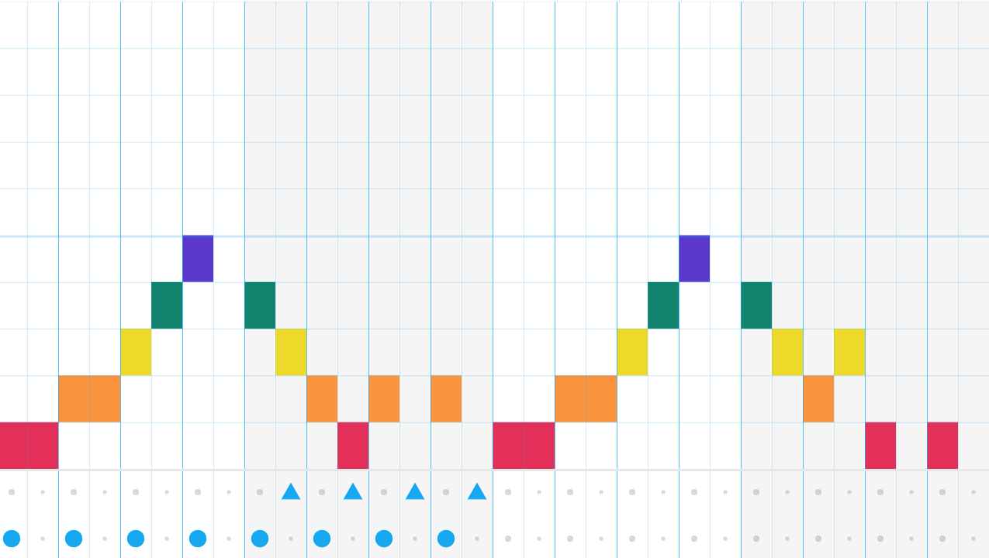

Note Name:
A
G
E
D
C

You can also add another layer in the 2nd octave (top half of the screen):
https://musiclab.chromeexperiments.com/Song-Maker/song/6550718538842112

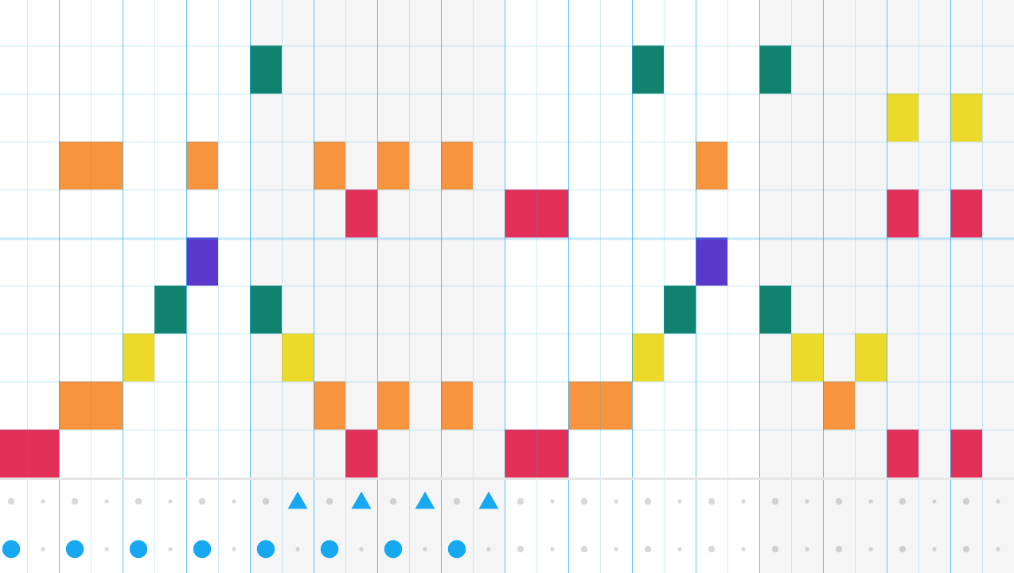
Lower pitch
Higher pitch
How does this sound? Can you hear the harmony?

Notice the REPEATING PATTERNS in the pulse, the chords and the melody!
Challenge:
How about adding chords (3 notes or more played at the same time) in the bottom half and the melody in the top half? This is an example of using chords (I have only outlined 3 of them):
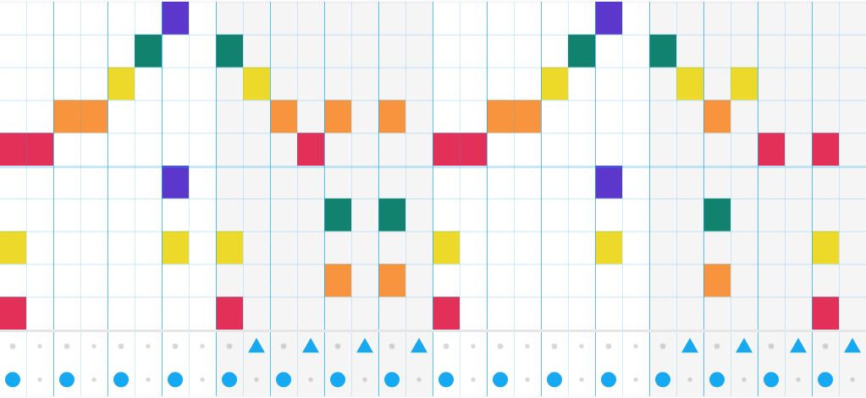

Notice I still have repeating patterns in the pulse, the chords and the melody!
Experiment and have fun!

