- Write out your 4x table below.
0 × 4 = 0
1 × 4 =
4 × 4 =
9 × 4 =
12 × 4 =
4× Table Search
- Find the sets of 3 numbers from your 4 x table number sentences. Colour them in.
They may be horizontal, vertical or diagonal. Write the ones you find underneath. One is done for you as an example.
5 | 9 | 8 | 3 | 4 | 12 | 17 | 23 | 28 | 6
25 | 6 | 4 | 44 | 19 | 4 | 1 | 7 | 13 | 4
10 | 12 | 9 | 36 | 16 | 16 | 4 | 12 | 4 | 11
4 | 2 | 13 | 18 | 4 | 8 | 4 | 6 | 22 | 28
40 | 4 | 22 | 4 | 33 | 6 | 5 | 18 | 14 | 2
19 | 8 | 32 | 15 | 14 | 11 | 4 | 44 | 44 | 48
2 | 28 | 4 | 10 | 13 | 8 | 6 | 24 | 34 | 4
15 | 16 | 8 | 49 | 5 | 4 | 20 | 10 | 7 | 12

4 x 4 = 16

4× Table Search Answers
- Write out your 4x table below
0 × 4 = 0
1 × 4 = 4
2 × 4 = 8
3 × 4 = 12
4 × 4 = 16
5 × 4 = 20
6 × 4 = 24
7 × 4 = 28
8 × 4 = 32
9 × 4 = 36
10 × 4 = 40
11 × 4 = 44
12 × 4 = 48
- Find the sets of 3 numbers from your 4x table number sentences. Colour them in. They may be horizontal,
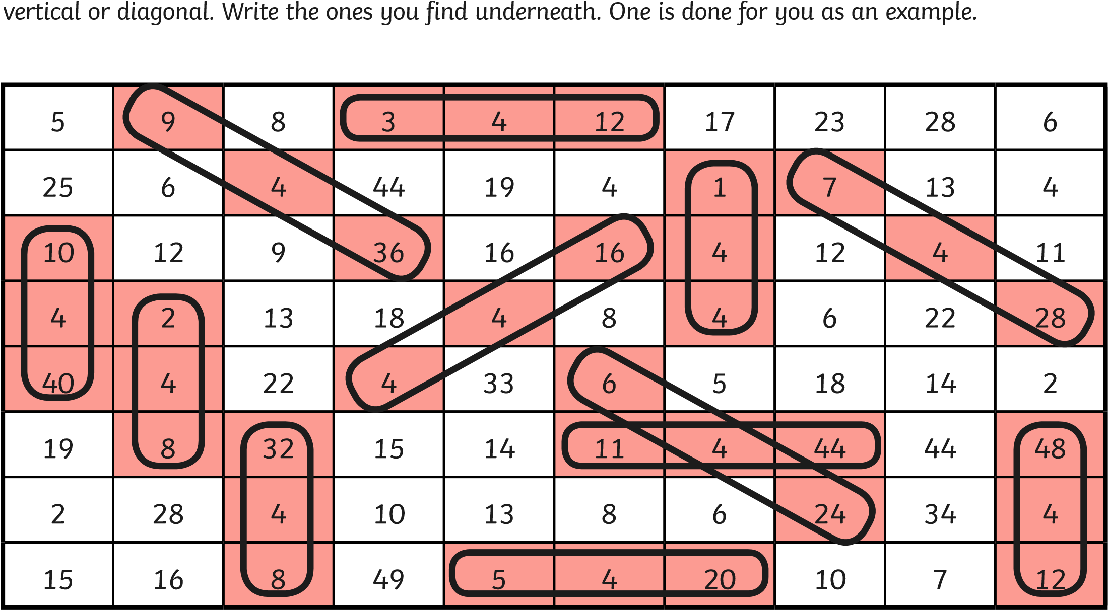

- 4 × 4 = 16
- 11 × 4 = 44
- 2 × 4 = 8
- 3 × 4 = 12
- 7 × 4 = 28
- 8 × 4 = 32
- 5 × 4 = 20
- 6 × 4 = 24
- 1 × 4 = 4
- 9 × 4 = 36
- 12 × 4 = 48
- 10 × 4 = 40

