27th April Y5 PSHE Task

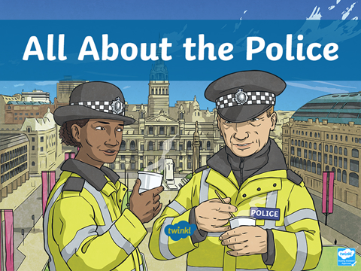

LO: To understand the role of police in Society.
Have a look at the following links. Pay close attention to the job that the police do. How do their personalities and skills help them to do that job?

https://www.youtube.com/watch?v=ignN_iwE5us
https://wiki.kidzsearch.com/wiki/Police

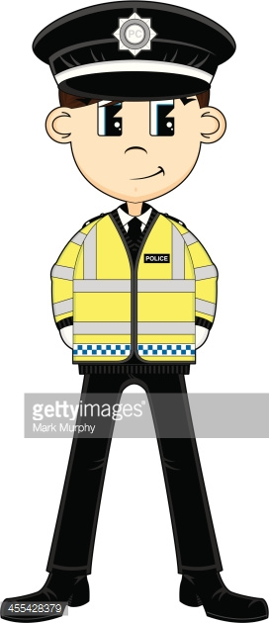
Find a grown up and Rally Robin a list of the skills you think it takes to be a police officer. Think about our school values to help you! Then annotate a picture, see the example below.

Fit Honest

