Year 5 – Home Learning
Wednesday 22nd April
Lesson and Learning Objective | Task
Maths  LO Adding decimals within 1  LO Subtracting decimals within 1 | Search White Rose Home Learning – Year 5  Click on Summer Term Week 1  Lesson 1  Today you will be learning how to add decimals within one whole. Just like last time you might want to use place value counters, if you don’t have these use counters or scrap paper to help and either create your own place value chart or download one from the internet. These resources will help you to understand how you exchange between columns. Remember 0.45 is 45 hundredths.  Open the video and complete the flashback 4 task. Then watch the video which helps you to understand how to add decimals. Then either print off the worksheet or answer the questions on a piece of paper.  Lesson 2  Now you’re going to move on to subtracting decimals using a variety of different methods. Some of you might like to use place value counters on a place value grid, just like yesterday. You’ll also explore subtraction as difference, using a number line to count on from the smaller decimal to the larger decimal. You’ll also use your knowledge of exchange within whole numbers to subtract decimals efficiently.  Click on Lesson 2 today, complete the flashback 4 task, then watch the video, remember if you’re not sure you could go back and watch parts again, then complete the task.  I’ve also attached a SAFE Maths Sheet, try to complete the sheet in 10 minutes, or give yourself a challenge and reduce the time.
English  LO: To improve writing using parenthesis | LO: To improve writing using parenthesis  Reread your facts about castles from the last piece of work you did. Using these bits of information, can you improve this simple paragraph with a focus on adding parenthesis?  A castle defends people from invaders. There are many parts of a castle. A portcullis protects the gate from enemies entering the castle. Enemies could have boiling oil poured on their head.  You must include:  - A clear topic sentence to open your paragraph and introduce what you are talking about  - Three examples of parenthesis using at least two pieces of punctuation (either brackets, dashes or commas)  Challenge (for those children who want an additional challenge when completing the task) – Can you engage your reader using authorial comment? For example: (boiling oil? I’m glad I didn’t try to attack castles in those days!)  Support (for those children who may require more support to complete the task) – Use the scaffold attached.
Reading  LO: To summarise key information. | We are starting to read our class guided reading book again ‘Wonder’. See the general help sheet attached which has links to the on-line book. Plus the activity for today with additional help for those who need it.
Spelling | Continue to practise your spellings. Can you remember the technical vocab from the castle work too?
Wider Curriculum  LO: To understand the concept of a life cycle  LO: To describe reproduction in a plant | We are now looking at ‘Living Things and Their Habitats’ with a focus on life styles and comparing them. First have a think back to Year 3 where we looked at parts of a plant and types of pollination and dispersal of seeds. Here is a reminder:  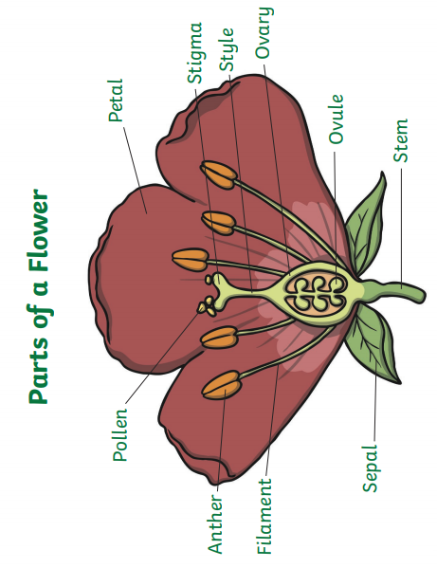  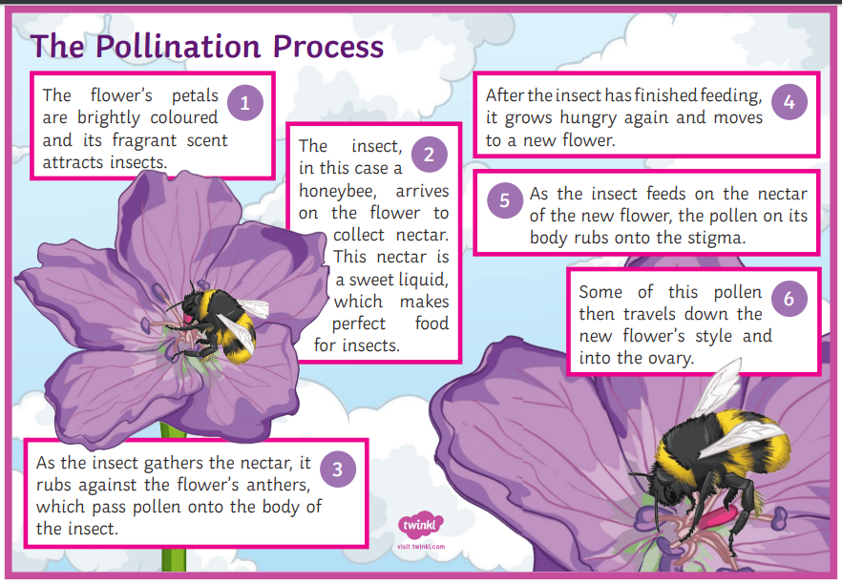  All living things need to make more of themselves so that their species does not die out. Reproduction is the process by which new living things are made. Pollen from the stamen (male part – men) is transferred to the stigma (female part – ma like Mum!) and that’s how seeds are fertilised through pollination.  Now to today’s learning. A life cycle shows the key stages in a creature’s life. Have you ever grown a sunflower or vegetables in your garden? Discuss with someone at home what stages the plant goes through from seed to the end of its life.  Watch this video of a bean plant: https://www.youtube.com/watch?v=w77zPAtVTuI/. What are the key parts of a plant’s life cycle that you can identify?  Now look through the attached presentation about a life cycle of a plant for more information.  Task – You choose how you would like to show the life cycle of a plant (I would choose a bean, sunflower or something you have seen growing before). You can use this glossary of key terms to help you add information to your life cycle. You may wish to make a poster, a booklet, a video, a storyboard, write a story of the life of a flower or - if you are already growing your own plants - you may want to create a plant diary observing changes over time.  Success Criteria – for this task you must:  - Outline the 5 main stages in the life cycle of a plant (germination, roots, leaves, flowering, seed dispersal)  - Include images or diagrams for each stage  - Correctly name each stage and describe what changes occur  Here is the glossary of terms you may wish to use (they are not in the order of the cycle!):  - Fertilisation – the pollen reaches another flower and travels to the ovary where it fertilises the egg cells to make seeds.  - Pollination – pollen produced by a flower is carried by insects or blown by the wind to another flower.  - Germination – the plant begins growing a seed, when the conditions are suitable.  - Seed Dispersal – the seeds are spread out so they can grow.  - Flower – the plant grows and develops flowers.  A scaffold has been attached should you need more support.  Challenge – can you embed some of your Y3 knowledge and use scientific parts of the plant, describe types of pollination or dispersal in your life cycle?  We are waiting for some sunflower seeds to arrive that we will hopefully deliver to you all or you can collect from the office to grow your own and observe the changes over time as your sunflower grows. We will keep you updated on this. In the meantime if you have any seeds of your own it would be lovely to see what you are growing.

