22nd April Y5 Reading Task
LO: To summarise key characters.
Read the blurb together.
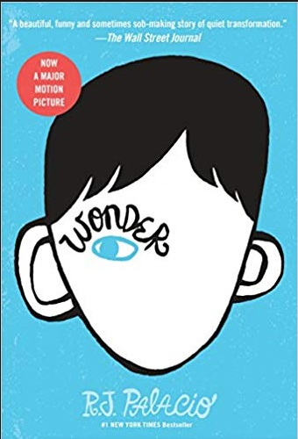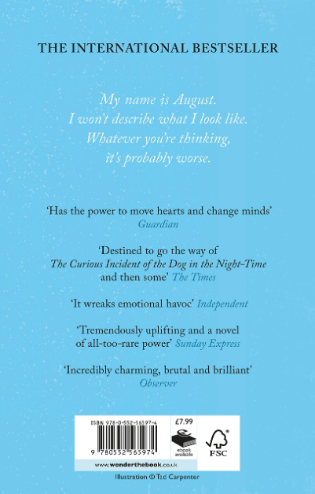

Watch the clip here and remind yourself what the book is about.
https://www.youtube.com/watch?v=fgB7_KpBDss
Talk to your grown up about what you already know, include:
- Who is the main character
- Why is he unusual
- Why do his parents worry about him starting school
- Why do think he is ‘a lamb to the slaughter’?
Support:
You can catch up on the audio link too.
Find and define the following words:

Shake

Combination

Mad

