Voici ma famille
L.O. I can present my family members using third person verbs.
WAGOLL
Voici… here is
ma my mon
Voici ma soeur. Elle s’appelle Megan. Elle a huit ans. Elle est sympa.
mère mother / father père
sœur sister / brother frère
belle-mère step-mum / dad beau-père
grand - mère grandma / pa grand - père
Voici mon père. Il s’appelle Kevin. Il a quarante ans. Il est intelligent.
cousine cousin cousin
tante aunt / uncle oncle

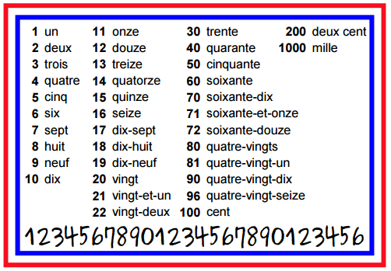
Elle s’appelle = she is called
Il s’appelle = he is called
Elle a + (____ans) = she has (she is +age)
Il a + (____ans) = he has (he is + age)
Elle est = She is
Il est = He is
amusant/e = funny | paresseux/ euse = lazy
bavard/e = chatty | sympa = nice
intelligent/e = intelligent | timide = shy
calme = quiet /calm | Sportif / sportive = sporty
poli(e) = polite | Pénible = annoying

