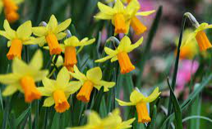
Newsletter

March 2023

Spring has definitely arrived this week with the clocks going forward and the daffodils in bloom around school. We have had another action packed, fun filled term and are looking forward to many outdoor activities in the summer term. Read on to see what the children have been up to! In the meantime, I wish you all a lovely holiday. | In this Issue:  World Book Day  Staff shout out  Parent shout out  FODs Disco  Red nose day  Y4 Art trip  Y5 Assembly  Y3 residential visit  Coming up:  27/3 Y4WL begin swimming lessons  17/4 school re-opens  21/4 Y5 squash trip  27/4 class school photos  1st May- Bank holiday- school closed  3 May-5 May Year 4 Mount Cook  5 May- Y5 squash visit  8 May- Bank holiday- school closed  9-12 May- Y6 SATs  26 May- break up
World Book Day and Book Fair
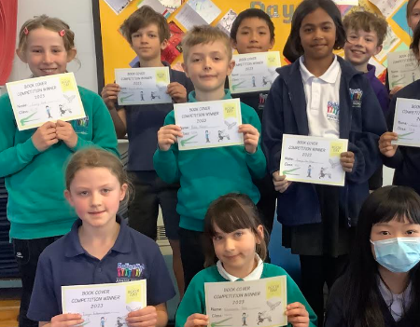
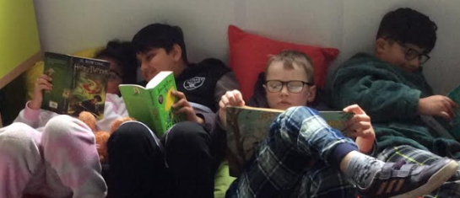
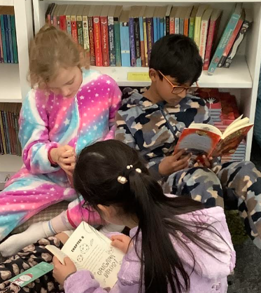
On Thursday 2nd March, DJS celebrated World Book Day. Children were asked to bring in their favourite book and could choose to wear pyjamas. The day was filled with opportunities to enjoy reading and find out more about each others’treasured books. We ran a competition for the children to create a book cover and blurb for the book they brought in. The results were breathtaking! Well done to the runners up: Molly, Sam, Georgina, Annie, Alex, Eliza, Mimi, Jessica, Avani, Nevaeh, Monty, and Seb and to the winners: Zain, Esme, Nate, Emily, Freya, Emmanuelle, Amaya, Chuanxi, Ewart, Sam, Beatrice and Zhi Tong! Alongside this, we hosted our annual book fair and sponsored read. The children raised a fabulous amount of money, which means that each class has been given £140 to spend on new books for their classroom! Thank you to all the Dobcroft families who helped raise this total. We hope the children enjoyed their day and look forward to World Book Day 2024!

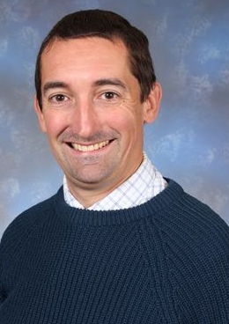
Staff Shout Out!
Well done to Mr Wassell who is our ‘Pride of Dobcroft’ Staff winner for February. Mr Wassell is one of our fabulous year 5 teachers who always goes above and beyond and is willing to help in any situation across school. This might be Saturday morning Cross Country, running a Y6 writing group or jumping in to do an assembly- just fabulous! A fully deserved award!

Parent Shout Outs

A really big thank you to our wonderful parents who volunteered to host an assembly this half term. First up was Nathan Oliver, who taught the children all about a career in architecture. Nathan explained to children how so many different curriculum subjects are involved in architecture. He showed them some amazing architectural designs, which children loved! The children were really inspired by the assembly and there are now many children in our school who are interested in becoming an architect.

Secondly, we had Katie Bennett in to share her experience of being a foster carer. This helped children to celebrate our value ‘together we embrace difference'. It was fabulous to see children asking so many thoughtful and sensible questions. Katie was brilliant at answering the children's questions and it was brilliant to see how much she loves this part of her life. A true inspiration to our children.

If you would like to join us in assembly to share your vocation or something special that will inspire the children, then please get in touch with akirk@dobcorft-junsheffield.sch.uk

FODs School Disco

This was our first disco party night since COVID and was a hugely popular event. Children danced, ate sweets, had nails painted or just relaxed in the quiet room playing board games. It was a lovely end of term event and one that I am sure will be repeated soon. Thank you to all of the staff and parents who volunteered their help. It is really appreciated as without volunteers such events can’t go ahead.
RED NOSE DAY
Once again, the DJS community have gone all out to support this incredibly important charity event. The Friday assembly was bright red - thank you for helping your children getting ready! Lessons were all comic relief themed, with maths code-breaking and SPaG hunt type activities. Each class took part in class quiz. The children in the winning team each received a certificate and a non- school uniform day.
It was a great day and we raised a whopping £475.50! So a huge thank you for your ongoing generosity - it’s a great cause!

Year 4 Art Trip

This half term, the Y4s have been learning about the art work of Sheffield's own Pete Mckee! In school, the children have been busy creating their own painting in the style of Pete Mckee and they have also been to Sheffield City Centre to spot one of his famous murals and other pieces of street art. When Y4JF went on their trip, they were lucky enough to meet a real street artist as Rob Lee was busy creating a new piece next to his famous "Now Then Then Now" painting. The children watched the artist at work and he spoke to them about his ideas and technique.

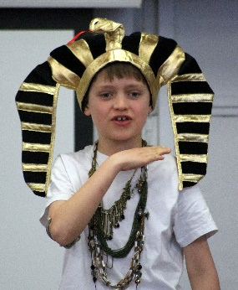
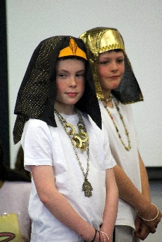
Year 5 Assembly to Parents
Our year 5 team finished the term off with a spectacular assembly. It was fabulous to welcome so many parents and grandparents into school for the event. They shared their learning relating to their history topic of the Ancient Egyptians. There were a whole host of talents and skills on show including singing and acting. Most importantly, the children really enjoyed putting together the performance and having their families to perform too. Well done year 5.
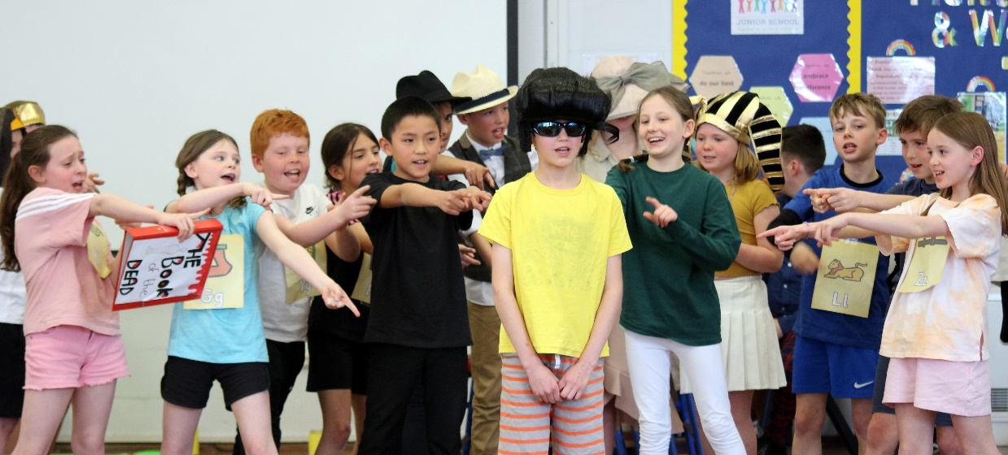

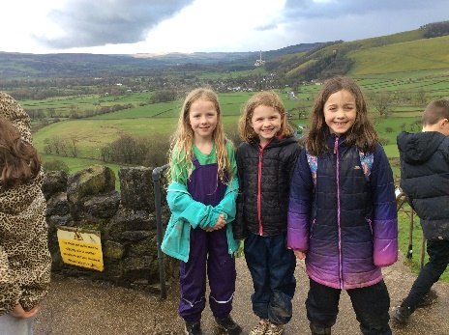
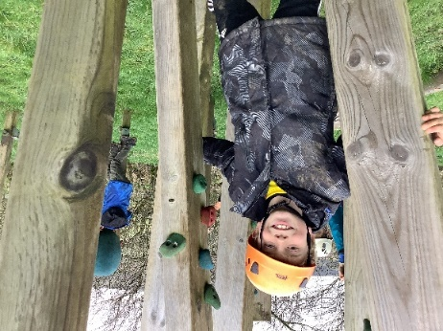
Year 3 residential Visit
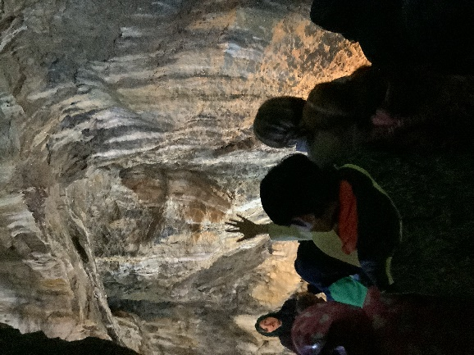
Our super year 3 children went on their first residential visit this week. They spent a night away in Castleton and had a wonderful time, including a visit to the caves. They were super excited on Wednesday morning. Other activities included orienteering; tackling a muddy obstacle course; creating a case for an egg so it wouldn’t crack when it was dropped from a height; scavenger hunting and an evening of loud and silly sing-songs around a campfire with hot chocolate and marshmallows. The children had fun in their dorms. The meals in the refectory were yummy and the kitchen staff congratulated the children on their beautiful manners, which made us really proud. It was a full on couple of days, but the Year 3s were super-mature!

Congratulations!
Congralutions to Miss Field and her partner who are getting married during the Easter holidays! We wish them every happiness and look forward to welcoming Mrs Barker to school after Easter.

Parkhead Cricket
Parkhead cricket club are soon starting their summer training and friendly games. Training is on Thursday evenings with games at various times depending on age groups, and all ages from Y3-Y6 are welcome. If you would be interested in joining this friendly local club please contact Will Forsdike on 07791 029014.

